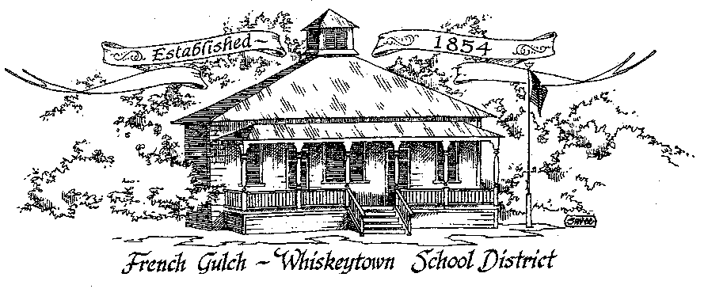

French Gulch-Whiskeytown School District
11442 Cline Gulch Rd., French Gulch, CA 96033
530-359-2151

SPECIAL MEETING OF THE GOVERNING BOARD
MINUTES

September 14, 2021 5:30 PM

OUR DISTRICT MISSION
The French Gulch-Whiskeytown School District is dedicated to building resourceful, respectful, academically strong individuals.
CALL TO ORDER & OPEN SESSION
5:00 PM

1. CALL TO ORDER
ROLL CALL
Heather VanHorn, President ☒ Lesley Pearson, Clerk ☒
Sara Wells ☒ Crystal Andersen ☒
2. OPPORTUNITY FOR PUBLIC COMMENT ON AGENDA ITEMS:

Public Comment on any item of interest to the public that is within the Board’s jurisdiction will be heard. The Board may limit comments to no more than 3 minutes pursuant to Board policy. Public comment will also be allowed on each specific agenda.

3. APPROVAL OF AGENDA:
1st: Lesley Pearson 2nd: Crystal Andersen Ayes: All Opposed: None
4. CORRESPONDENCE:
Jack Schrader’s rates are going up for the Developer Fee studies

5. APPROVAL OF MINUTES:
5.1 APPROVE MINUTES OF THE AUGUST 9, 2021 BOARD MEETING
1st: Crystal Andersen 2nd: Sara Wells Ayes: All Opposed: None
6. REPORTS AND PUBLIC FORUM: (if applicable)
6.1 SUPERINTENDENT REPORT
a. revision of reopening plan
The reopening plan is posted to our website. It is in revision to make sure all elements are accounted for as things change on a regular basis during Covid. We have to provide an opportunity for students who choose Independent Study to have synchronous instruction. As we have throughout all of Covid, we are struggling with the Digital Divide in this small town. We were interested in applying for a waiver that was discouraged by Judy Flores. She said as long as there is telecommunication, via phone call or FaceTime, we are okay.
b. update on first 4 weeks of school
It is going pretty smoothly.
c. plans for “paper” Open House
We are going to do a “paper” Open House. Ms. Hill and Ms. Swayne will roll out school expectations., curriculum, policies to the parents through this paper Open House
d. text book orders social studies and science K-8
We have a large order of new text books that arrived from McGraw Hill. They are Social Studies (Impact CA) and Science (Integrated Science). Each grade will be receiving new text books.
e. temporary aide assistance in upper elementary
Maureen is coming twice a week to help in the 5-8 class. She is pulling kids from the class to work independently and also working with the advanced Math group. Rita Stanley who was our distance learning Math teacher is no longer offering her services. We are still looking for someone to fill Rita’s vacancy.

7. DISCUSSION ITEMS and/or PUBLIC HEARING: (if applicable)
7.1 PUBLIC FORUM HEARING OF PERSONS WISHING TO ADDRESS THE BOARD
Open Public Hearing to receive comments on the Adoption of Resolution 9-21-22, that every pupil has sufficient or insufficient textbooks/instructional materials consistent with the cycles of the curriculum framework adopted by the State Board of Education.

7.2 CONAPP REPORT UPDATE-

Patty sent an update for the Consolidated App from June 2021.
We are not Title I due to results of the 2010 Census. We get $19,000 in REAP funds that we use for teachers’ salaries.

8. ACTION ITEMS:
8.1 APPROVAL OF THE WARRANTS: 8/9/2021 to 9/10/2021
1st: Lesley Pearson 2nd: Crystal Andersen Ayes: All Opposed: None
8.2 APPROVAL OF RESOLUTION 9-21-22 REGARDING THE SUFFICIENCY OF INSTRUCTIONAL MATERIALS
1st: Sara Wells 2nd: Crystal Andersen Ayes: All Opposed: None
8.3 APPROVAL OF THE 20-21 UNAUDITED ACTUALS
1st: Lesley Pearson 2nd: Crystal Andersen Ayes: All Opposed: None
8.4 APPROVAL OF THE RESOLUTION 1-21-22 FOR ADOPTING THE GANN LIMIT
1st: Sara Wells 2nd: Crystal Andersen Ayes: All Opposed: None
8.5 APPROVAL OF THE WARRANT SIGNATURE CARD FOR 2021-2022 SCHOOL YEAR
1st: Lesley Pearson 2nd: Sara Wells Ayes: All Opposed; None
8.6 APPROVAL OF BOARD POLICY 6158: INDEPENDENT STUDY
1st: Lesley Pearson 2nd: Crystal Andersen Ayes: All Opposed: None
8.7 APPROVAL OF ADMINISTRATIVE REGULATION 6158: INDEPENDENT STUDY
1st: Sara Wells 2nd: Lesley Pearson Ayes All Opposed: None

9. PLANNING:
9.1 ITEMS FROM THE FLOOR: Comments, Suggestions for future meetings, etc.
Lesley brought to the floor that Mondays are tough for her, as they are for Sara.
We would like to have the meeting on Tuesdays.

9.2 Next Regular Meeting of the Board: OCTOBER 5, 2021 at 5:00 PM

10. ADJOURNMENT:
10.1 Adjourn Meeting

In compliance with the Americans with Disabilities Act, the French Gulch-Whiskeytown School District will make available to any member of the public who has a disability, appropriate disability-related modifications or accommodations in order for that person to participate in the public meeting. Contact Kristin George in the Office of the Superintendent, French Gulch-Whiskeytown School District Office, 11442 Cline Gulch Rd., French Gulch, California, at (530) 359-2151 at least 48 hours prior to the scheduled meeting. We will make every effort to give primary consideration to expressed preferences, or provide equally effective means of communication to ensure equal access to French Gulch-Whiskeytown School District public meetings.
All documents presented to the members of the Governing Board for consideration at this meeting are included in this agenda packet. Documents unavailable at the time of the printing of this agenda are available for public review in the District Office, 11442 Cline Gulch Rd, during regular business hours. The public is invited and encouraged to attend and participate in Board Meetings. Persons wishing to address the Board may do so during the meeting.

