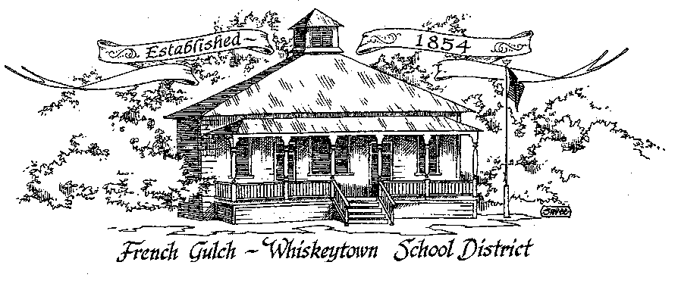

French Gulch-Whiskeytown School District
11442 Cline Gulch Rd., French Gulch, CA 96033
530-359-2151

SPECIAL MEETING OF THE GOVERNING BOARD

September 14, 2021 5:30 PM

OUR DISTRICT MISSION
The French Gulch-Whiskeytown School District is dedicated to building resourceful, respectful, academically strong individuals.
CALL TO ORDER & OPEN SESSION
5:00 PM

1. CALL TO ORDER
ROLL CALL
Heather VanHorn, President ☐ Lesley Pearson, Clerk ☐
Sara Wells ☐ Crystal Andersen ☐
2. OPPORTUNITY FOR PUBLIC COMMENT ON AGENDA ITEMS:

Public Comment on any item of interest to the public that is within the Board’s jurisdiction will be heard. The Board may limit comments to no more than 3 minutes pursuant to Board policy. Public comment will also be allowed on each specific agenda.

3. APPROVAL OF AGENDA:

4. CORRESPONDENCE:

5. APPROVAL OF MINUTES:
5.1 APPROVE MINUTES OF THE AUGUST 9, 2021 BOARD MEETING

6. REPORTS AND PUBLIC FORUM: (if applicable)
6.1 SUPERINTENDENT REPORT
a. revision of reopening plan
b. update on first 4 weeks of school
c. plans for “paper” Open House
d. text book orders social studies and science K-8
e. temporary aide assistance in upper elementary

7. DISCUSSION ITEMS and/or PUBLIC HEARING: (if applicable)
7.1 PUBLIC FORUM HEARING OF PERSONS WISHING TO ADDRESS THE BOARD
Open Public Hearing to receive comments on the Adoption of Resolution 9-21-22, that every pupil has sufficient or insufficient textbooks/instructional materials consistent with the cycles of the curriculum framework adopted by the State Board of Education.

7.2 CONAPP REPORT UPDATE

8. ACTION ITEMS:
8.1 APPROVAL OF THE WARRANTS: 8/9/2021 to 9/10/2021
8.2 APPROVAL OF RESOLUTION 9-21-22 REGARDING THE SUFFICIENCY OF INSTRUCTIONAL MATERIALS
8.3 APPROVAL OF THE 20-21 UNAUDITED ACTUALS
8.4 APPROVAL OF THE RESOLUTION 1-21-22 FOR ADOPTING THE GANN LIMIT
8.5 APPROVAL OF THE WARRANT SIGNATURE CARD FOR 2021-2022 SCHOOL YEAR
8.6 APPROVAL OF BOARD POLICY 6158: INDEPENDENT STUDY
8.7 APPROVAL OF ADMINISTRATIVE REGULATION 6158: INDEPENDENT STUDY

9. PLANNING:
9.1 ITEMS FROM THE FLOOR: Comments, Suggestions for future meetings, etc.
9.2 Next Regular Meeting of the Board: OCTOBER 11, 2021 at 5:00 PM

10. ADJOURNMENT:
10.1 Adjourn Meeting

In compliance with the Americans with Disabilities Act, the French Gulch-Whiskeytown School District will make available to any member of the public who has a disability, appropriate disability-related modifications or accommodations in order for that person to participate in the public meeting. Contact Kristin George in the Office of the Superintendent, French Gulch-Whiskeytown School District Office, 11442 Cline Gulch Rd., French Gulch, California, at (530) 359-2151 at least 48 hours prior to the scheduled meeting. We will make every effort to give primary consideration to expressed preferences, or provide equally effective means of communication to ensure equal access to French Gulch-Whiskeytown School District public meetings.
All documents presented to the members of the Governing Board for consideration at this meeting are included in this agenda packet. Documents unavailable at the time of the printing of this agenda are available for public review in the District Office, 11442 Cline Gulch Rd, during regular business hours. The public is invited and encouraged to attend and participate in Board Meetings. Persons wishing to address the Board may do so during the meeting.

