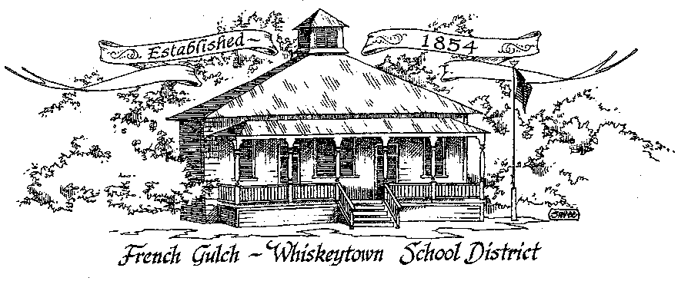

Successful Students Today – Successful Citizens Tomorrow

French Gulch-Whiskeytown School District
11442 Cline Gulch Rd., French Gulch, CA 96033
530-359-2151

REGULAR MEETING OF THE GOVERNING BOARD

September 14, 2020 5:00 PM

OUR DISTRICT MISSION
The French Gulch-Whiskeytown School District is dedicated to building resourceful, respectful, academically strong individuals.
CALL TO ORDER & OPEN SESSION
5:00 PM

1. CALL TO ORDER
ROLL CALL
Heather VanHorn, President ☐ Lesley Pearson, Clerk ☐
Sara Wells ☐ Keli Laws ☐
2. OPPORTUNITY FOR PUBLIC COMMENT ON AGENDA ITEMS:

Public Comment on any item of interest to the public that is within the Board’s jurisdiction will be heard. The Board may limit comments to no more than 3 minutes pursuant to Board policy. Public comment will also be allowed on each specific agenda.

3. APPROVAL OF AGENDA:

4. CORRESPONDENCE:
4.1 HEATHER VAN HORN LETTER TO THE GRAND JURY
4.2 LOCAL CONTROL AND ACCOUNTABILITY PLAN FEDERAL ADDENDUM

5. APPROVAL OF MINUTES:
5.1 APPROVE MINUTES OF THE AUGUST 10, 2020 BOARD MEETING

6. REPORTS AND PUBLIC FORUM: (if applicable)
6.1 SUPERINTENDENT REPORT
a. Review of first four weeks
b. Enrollment
c. Update on Covid-19 guidelines in place
d. Office Equipment Upgrade
e. Communication with family members

7. DISCUSSION ITEMS and/or PUBLIC HEARING: (if applicable)
7.1 PUBLIC FORUM HEARING OF PERSONS WISHING TO ADDRESS THE BOARD
Open Public Hearing to receive comments on the Adoption of Resolution 9-20-21, that every pupil has sufficient or insufficient textbooks/instructional materials consistent with the cycles of the curriculum framework adopted by the State Board of Education.

7.2 PRESENTATION OF THE LEARNING CONTINUITY PLAN

7.3 PRESENTATION OF THE 19-20 UNAUDITED ACTUALS

7.4 DISCUSSION ON: THE SUMMARY OF THE MAJOR PROVISIONAL AND REQUIREMENTS OF THE RALPH M. BROWN ACT

8. ACTION ITEMS:
8.1 APPROVAL OF THE WARRANTS: 8/12/2020 - 9/11/2020
8.2 APPROVAL OF RESOLUTION #9-20-21 REGARDING THE SUFFICIENCY OF INSTRUCTIONAL MATERIALS
8.3 APPROVAL OF THE 2020-2021 CONNAPP

9. PLANNING:
9.1 ITEMS FROM THE FLOOR: Comments, Suggestions for future meetings, etc.
9.2 Next Special Meeting of the Board: SEPTEMBER 16, 2020 at 5:00 PM
9.3 Next Regular Meeting of the Board: OCTOBER 12, 2020 at 5:00 PM

10. ADJOURNMENT:
10.1 Adjourn Meeting

In compliance with the Americans with Disabilities Act, the French Gulch-Whiskeytown School District will make available to any member of the public who has a disability, appropriate disability-related modifications or accommodations in order for that person to participate in the public meeting. Contact Kristin George in the Office of the Superintendent, French Gulch-Whiskeytown School District Office, 11442 Cline Gulch Rd., French Gulch, California, at (530) 359-2151 at least 48 hours prior to the scheduled meeting. We will make every effort to give primary consideration to expressed preferences, or provide equally effective means of communication to ensure equal access to French Gulch-Whiskeytown School District public meetings.
All documents presented to the members of the Governing Board for consideration at this meeting are included in this agenda packet. Documents unavailable at the time of the printing of this agenda are available for public review in the District Office, 11442 Cline Gulch Rd, during regular business hours. The public is invited and encouraged to attend and participate in Board Meetings. Persons wishing to address the Board may do so during the meeting.

