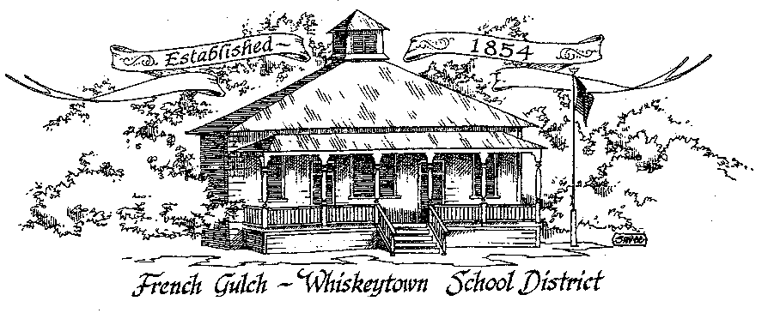

French Gulch-Whiskeytown School District
11442 Cline Gulch Rd., French Gulch, CA 96033
530-359-2151

SPECIAL MEETING OF THE GOVERNING BOARD

October 5, 2021 5:00 pm

OUR DISTRICT MISSION
The French Gulch-Whiskeytown School District is dedicated to building resourceful, respectful, academically strong individuals.
CALL TO ORDER & OPEN SESSION
5:00 PM

1. CALL TO ORDER
ROLL CALL
Heather VanHorn, President ☐ Lesley Pearson, Clerk ☐
Crystal Andersen ☐ Sara Wells ☐

2. OPPORTUNITY FOR PUBLIC COMMENT ON AGENDA ITEMS

Public Comment on any item of interest to the public that is within the Board’s jurisdiction will be heard. The Board may limit comments to no more than 3 minutes pursuant to Board policy. Public comment will also be allowed on each specific agenda.

3. APPROVAL OF AGENDA -

4. CORRESPONDENCE -
4.1 LETTER TO THE GOVERNING BOARD FROM MOUNTAIN VALLEY JPA
4.2 LETTER TO THE GOVERNING BOARD FROM JESSICA BIGBY REGARDING LCAP & BUDGET APPROVAL

5. APPROVAL OF MINUTES-
5.1 APPROVAL OF MINUTES FROM SEPTEMBER 14, 2021 SPECIAL BOARD MEETING
5.2 APPROVAL OF MINUTES FROM MAY 12, 2021 SPECIAL BOARD MEETING

6. REPORTS AND PUBLIC FORUM (if applicable) -
6.1 SUPERINTENDENT REPORT:
a. Buddy Bench
b. ECF Award
c. Federal Kitchen Grant Process
d. Pro Pacific work around (weekly fresh produce delivery)
e. Kid’s Menu Survey

7. DISCUSSION ITEMS and/or PUBLIC HEARING (if applicable)-
7.1 PRESENTATION OF 2020-21 CAASPP RESULTS
7.2 ONSITE COVID TESTING REVISITED/SICK LEAVE RELATED TO COVID FOR FGWS STAFF
7.3 PARENT STUDENT HANDBOOK CONTENT
7.4 PROCESS OF ADJOURNING A REGULARLY SCHEDULED MEETING AND RESCHEDULING
8. ACTION ITEMS -
8.1 APPROVAL OF WARRANTS: SEPTEMBER 15,2021 – OCTOBER 4, 2021
8.2 APPROVAL OF WILLIAMS QUARTERLY FOR FIRST QUARTER 2021-2022

9. PLANNING
9.1 ITEMS FROM THE FLOOR: Comments, Suggestions for future meetings, etc.
9.2 Next Regular Meeting of the Board: November 2, 2021 at 5:00 PM
9.3 OTHER IMPORTANT DATES:

10. ADJOURNMENT
10.1 Adjourn Meeting

In compliance with the Americans with Disabilities Act, the French Gulch-Whiskeytown School District will make available to any member of the public who has a disability, appropriate disability-related modifications or accommodations in order for that person

to participate in the public meeting. Contact Kristin George in the Office of the Superintendent, French Gulch-Whiskeytown School District Office, 11442 Cline Gulch Rd., French Gulch, California, at (530) 359-2151 at least 48 hours prior to the scheduled meeting.

We will make every effort to give primary consideration to expressed preferences, or provide equally effective means of communication to ensure equal access to French Gulch-Whiskeytown School District public meetings.
All documents presented to the members of the Governing Board for consideration at this meeting are included in this agenda packet. Documents unavailable at the time of the printing of this agenda are available for public review in the District Office, 11442 Cline Gulch Rd, during regular business hours. The public is invited and encouraged to attend and participate in Board Meetings. Persons wishing to address the Board may do so during the Opportunity for Public Comment. Speakers are limited to three minutes each. Other opportunities to address the Board include the Public Forum and Items from the Floor. By law, the Board is not allowed to take action on matters that are not on the agenda.

