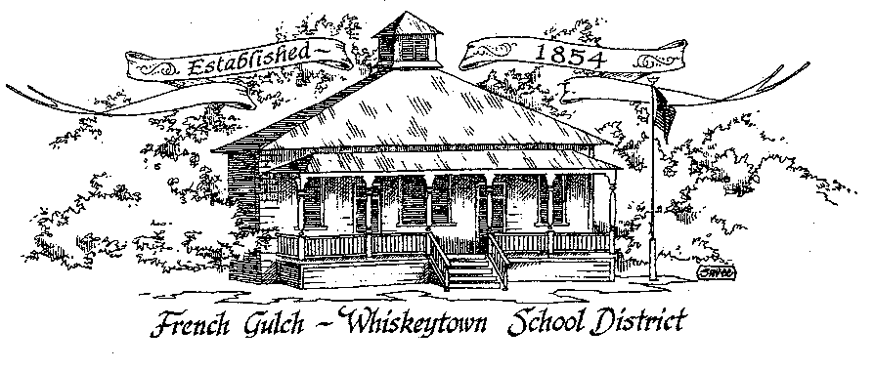

French Gulch-Whiskeytown School District
11442 Cline Gulch Rd., French Gulch, CA 96033
530-359-2151

REGULAR MEETING OF THE GOVERNING BOARD

October 12, 2020 5:00 pm

MINUTES

OUR DISTRICT MISSION
The French Gulch-Whiskeytown School District is dedicated to building resourceful, respectful, academically strong individuals.
CALL TO ORDER & OPEN SESSION
5:00 PM

1. CALL TO ORDER
ROLL CALL
Heather VanHorn, President ☒ Lesley Pearson, Clerk ☒
Keli Laws ☒ Sara Wells ☒

2. OPPORTUNITY FOR PUBLIC COMMENT ON AGENDA ITEMS

Public Comment on any item of interest to the public that is within the Board’s jurisdiction will be heard. The Board may limit comments to no more than 3 minutes pursuant to Board policy. Public comment will also be allowed on each specific agenda.

3. APPROVAL OF AGENDA -
1st: Keli Laws 2nd: Sara Wells Ayes: All
4. CORRESPONDENCE -
4.1 SCOE LETTER ON ORAL HEALTH DATA COLLECTION FOR KINDERGARTEN STUDENTS
4.2 LETTER TO GOVERNING BOARD FROM MOUNTAIN VALLEY JPA

5. APPROVAL OF MINUTES-
5.1 APPROVAL OF MINUTES FROM SEPTEMBER 14, 2020 REGULAR BOARD MEETING
1st: Lesley Pearson 2nd: Sara Wells Ayes: All
6. REPORTS AND PUBLIC FORUM (if applicable) -
6.1 SUPERINTENDENT REPORT:
A. Shasta County Health Department Guidelines for Schools regarding COvid-19
There are literal daily changes in Guidelines for Covid-19 in Shasta County. Schools are a crazy place to be right now. Moira has a new Symptom Tree that we are using as a guideline. (Included) Shasta Co is moving into the “purple” tier which is the highest/worst on Covid Meter. Heather who is a Director at Dignity said that people in closed spaces for 13 minutes or more with no masks are susceptible to it.
Our Blackboard Connect to the FGWS parents after the Board Meeting:
“FGWS Parents, Shasta Co. is moving into the “widespread” tier of Covid 19. After discussion, the School Board thought it prudent to remain on a Hybrid learning model. We will revisit this at the next Board Meeting on November 9th.
B. Additional personnel to mitigate learning loss
We have monies allocated for minimizing learning loss at this time of Hybrid learning. Ember is working on reading and Maureen Saari can be on boarded when needed for Linda’s class when Donna goes up to Renay’s Classroom in the afternoon. We are still looking for a substitute for Linda’s class as she is gone for the rest of the year, 2020, after Nov 19.

7. DISCUSSION ITEMS and/or PUBLIC HEARING (if applicable)-
7.1 RETURN TO 5 DAY/WEEK FACE TO FACE INSTRUCTION

8. ACTION ITEMS -
8.1 APPROVAL OF WARRANTS: SEPTEMBER 10 – OCTOBER 9, 2020
1st: Sara Wells 2nd: Keli Laws Ayes: All
8.2 APPROVAL OF WILLIAMS QUARTERLY FOR FIRST QUARTER 2020-2021
1st: Sara Wells 2nd: Keli Laws Ayes: All
8.3 APPROVAL OF RESOLUTION 11-20-21 REGARDING GOVERNING BOARD MEMBER, KELI LAWS APPOINTMENT IN LIEU OF ELECTION
1st: Sara Wells 2nd: Lesley Pearson Ayes: All
8.4 APPROVAL OF RESOLUTION 12-20-21 REGARDING GOVERNING BOARD MEMBER, SARA WELLS APPOINTMENT IN LIEU OF ELECTION
1st: Keli Laws 2nd: Lesley Pearson Ayes: All
8.5 ADMINISTER OATH OF OFFICE TO KELI LAWS AND SARA WELLS
Oath Administered by Board President Heather Van Horn
8.6 APPROVE OF RETURN TO 5 DAY/WEEK FACE TO FACE INSTRUCTION
1st: Keli Laws 2nd: Sara Wells Ayes: None
8.5 APPROVAL OF CSBA BOARD POLICY UPDATES:
1st: Keli Laws 2nd: Sara Wells Ayes: All
BP 0430 Comprehensive Local Plan for Special Education
AR 0430 Comprehensive Local Plan for Special Education
BP 0470 COVID-19 Mitigation Plan
BP 1312.3 Uniform Complaint Procedure
AR 1312.3 Uniform Complaint Procedure
E 1312.3 Uniform Complaint Procedure
AR 1312.4 Williams Uniform Complaint Procedures
BP 1340 Access to District Records
AR 1340 Access to District Records
BP 3471 Parcel Taxes- This BP was removed from the docket and was not approved
AR 3231 Impact Aid
BP 3551 Food Service Operations/Cafeteria Fund
AR 3551 Food Service Operations/Cafeteria Fund
BP 3555 Nutrition Program Compliance
E 3555 Nutrition Program Compliance
AR 4030 Nondiscrimination in Employment
BP 4112.9 4212.9, 4312.9 Employee Notifications
E 4112.9 4212.9, 4312.9 Employee Notifications

BP 4113 Assignment
AR 4113 Assignment
BP 4112.2 Certification
BP 4113.5 Working Remotely
BP 4119.11 4219.11 4319.11 Sexual Harassment
AR 4119.11 4219.11 4319.11 Sexual Harassment
BP 4119.12 Title IX Sexual Harassment Complaint Procedures
AR 4119.2 Title IX Sexual Harassment Complaint Procedures
BP 4351, 4152, 4251 Employee Compensation
BP 4219.13 4119.43 4319.43 Universal Precautions
AR 4219.43 4119.43 4319.43 Universal Precautions

BP 4213.5 Working Remotely
BP 5141.22 Infectious Diseases
AR 5141.22 Infectious Diseases
BP 5141.5 Mental Health
BP 5141.52 Suicide Prevention
BP 5145.3 Nondiscrimination/Harassment
AR 5145.3 Nondiscrimination/Harassment
BP 5145.6 Parental Notifications
E 5145.6 Parental Notifications

BP 5145.7 Sexual Harassment
AR 5145.7 Sexual Harassment
BP 6020 Parent Involvement
AR 6020 Parent Involvement
BP 6115 Ceremonies and Observances
AR 6115 Ceremonies and Observances
BP 6142.7 Physical Education an Activity
AR 6142.7 Physical Education an Activity
BP 6157 Distance Learning
BP 6159 Individualized Education Program
AR 6159 Individualized Education Program
BP 6159.1 Procedural Safeguards and Complaints for Special Education
AR 6159.1 Procedural Safeguards and Complaints for Special Education
AR 6173.4 Title VI Indian Education Programs- Was not voted on, will revisit at November Meeting

9. PLANNING
9.1 ITEMS FROM THE FLOOR: Comments, Suggestions for future meetings, etc.
9.2 Next Regular Meeting of the Board: November 9, 2020 at 5:00 PM
9.3 OTHER IMPORTANT DATES:

10. ADJOURNMENT
10.1 Adjourn Meeting

In compliance with the Americans with Disabilities Act, the French Gulch-Whiskeytown School District will make available to any member of the public who has a disability, appropriate disability-related modifications or accommodations in order for that person

to participate in the public meeting. Contact Kristin George in the Office of the Superintendent, French Gulch-Whiskeytown School District Office, 11442 Cline Gulch Rd., French Gulch, California, at (530) 359-2151 at least 48 hours prior to the scheduled meeting.

We will make every effort to give primary consideration to expressed preferences, or provide equally effective means of communication to ensure equal access to French Gulch-Whiskeytown School District public meetings.
All documents presented to the members of the Governing Board for consideration at this meeting are included in this agenda packet. Documents unavailable at the time of the printing of this agenda are available for public review in the District Office, 11442 Cline Gulch Rd, during regular business hours. The public is invited and encouraged to attend and participate in Board Meetings. Persons wishing to address the Board may do so during the Opportunity for Public Comment. Speakers are limited to three minutes each. Other opportunities to address the Board include the Public Forum and Items from the Floor. By law, the Board is not allowed to take action on matters that are not on the agenda.

