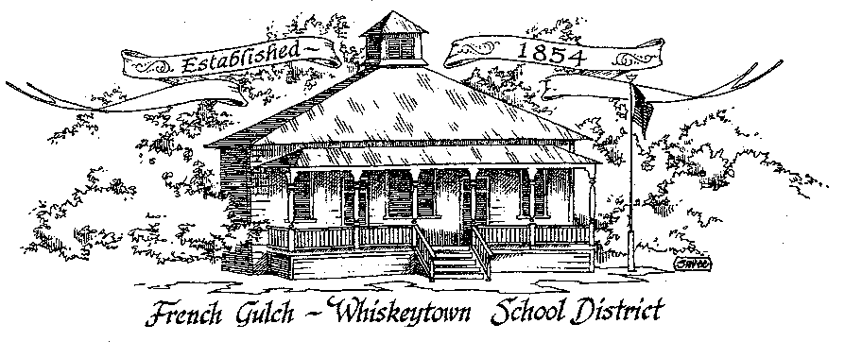

French Gulch-Whiskeytown School District
11442 Cline Gulch Rd., French Gulch, CA 96033
530-359-2151

MEETING OF THE GOVERNING BOARD

NOVEMBER 2, 2021

OUR DISTRICT MISSION
The French Gulch-Whiskeytown School District is dedicated to building resourceful, respectful, academically strong individuals.
CALL TO ORDER & OPEN SESSION
5:00 PM

1. CALL TO ORDER
ROLL CALL
Heather VanHorn, President ☐ Lesley Pearson, Clerk ☐
Crystal Andersen ☐ Sara Wells ☐
2. OPPORTUNITY FOR PUBLIC COMMENT ON AGENDA ITEMS

Public Comment on any item of interest to the public that is within the Board’s jurisdiction will be heard. The Board may limit comments to no more than 3 minutes pursuant to Board policy. Public comment will also be allowed on each specific agenda.

3. APPROVAL OF AGENDA:

4. CORRESPONDENCE
4.1 LEGAL UPDATE REGARDING THE “MENSTRUAL EQUITY FOR ALL ACT OF 2021” ASSURING THAT ALL WOMEN’S, ALL GENDER AND MEN’S BATHROOMS GRADES 6-12 HAVE AN ADEQUATE STOCK ON MENSTRUAL PRODUCTS
4.2 CALSHAPE VENTILATION GRANT PROGRAM- FROM PATTY BLYTHE

5. APPROVAL OF MINUTES:
5.1 APPROVE MINUTES OF OCTOBER 5, 2021 SPECIAL BOARD MEETING
5.2 APPROVE MINUTES OF THE OCTOBER 11, 2021 REGULAR BOARD MEETING

6. REPORTS AND PUBLIC FORUM: (if applicable)
  - SUPERINTENDENT REPORT:

- December is the month in which CA public school boards have their annual organizational meetings for the upcoming calendar year. At this meeting, which can take place at the regularly scheduled meeting time, or be an additional meeting. Offices for the Board may be reassigned and the regular meeting day and time are decided upon. The day and time can remain the same or be changed. This is often a meeting when a district established priorities for the year ahead.
- AB 1227 Human Trafficking Education grades 7-12 WEAVE Curriculum
- Possible ADA Correction
- PreK Programs
- Federal Kitchen Grant status
- Return of school milk cartons!
- Meeting with CSBA representative on November 29 5:30 pm at the SCOE PDC

7. DISCUSSION ITEMS and/or PUBLIC HEARING (if applicable)
7.1 RAISING PETTY CASH FROM $250.00 TO $500.00
7.2 COLUMBIA ELEMENTARY SCHOOL DISTRICT BOARD RESOLUTION 2122-10

Adjourn to Closed Session
CONFERENCE WITH LEGAL COUNSEL - ANTICIPATED LITIGATION
Significant Exposure to Litigation - Government Code Section 54956.9(d)(2)
1 potential case

Report out on Closed Session

7.3 CDE EMAIL RESPONSE TO CCSEESA REGARDING SCHOOL BOARDS REJECTING VACCINATION REQUIREMENTS
7.4 PROPOSED SHASTA COUNTY SUPERINTENDENTS LETTER TO REPRESENTATIVE DAHLE
7.5 EDUCATORS EFFECTIVENESS GRANT PROPOSAL
7.6 AB 438 LAYOFF NOTICE CHANGE FOR CLASSIFIED STAFF
7.7 HOME ANTIGEN KITS AVAILABLE TO COMMUNITY MEMBERS FORM THE SCHOOL

8. ACTION ITEMS:
8.1 APPROVAL OF THE WARRANTS 10/4/2021 to 11/01/2021
8.2 APPROVAL OF RESOLUTION 30-21-22, ESTABLISHING PETTY CASH OF $500
8.3 APPROVAL OF DATE FOR ORGANIZATIONAL MEETING IN DECEMBER 2021

9. PLANNING
9.1 ITEMS FROM THE FLOOR: Comments, Suggestions for future meetings, etc.
9.2 OTHER IMPORTANT DATES:
NOVEMBER 8-12 PARENT -TEACHER CONFERENCES, MINIMUM DAYS
NOVEMBER 9- PICTURE DAY
NOVEMBER 10- FGWS CEMETERY VISIT TO PLACE FLAGS ON VETERANS HEADSTONES
NOVEMBER 11- NO SCHOOL -VETERANS DAY
NOVEMBER 12- MAKE UP DAY FOR LATE START TO 2021-22 ACADEMIC YEAR
NOVEMBER 22-26- THANKSGIVING BREAK

10. ADJOURNMENT
10.1 Adjourn Meeting

In compliance with the Americans with Disabilities Act, the French Gulch-Whiskeytown School District will make available to any member of the public who has a disability, appropriate disability-related modifications or accommodations in order for that person to participate in the public meeting. Contact Kristin George in the Office of the Superintendent, French Gulch-Whiskeytown School District Office, 11442 Cline Gulch Rd., French Gulch, California, at (530) 359-2151 at least 48 hours prior to the scheduled meeting. We will make every effort to give primary consideration to expressed preferences, or provide equally effective means of communication to ensure equal access to French Gulch-Whiskeytown School District public meetings.
All documents presented to the members of the Governing Board for consideration at this meeting are included in this agenda packet. Documents unavailable at the time of the printing of this agenda are available for public review in the District Office, 11442 Cline Gulch Rd, during regular business hours. The public is invited and encouraged to attend and participate in Board Meetings. Persons wishing to address the Board may do so during the Opportunity for Public Comment. Speakers are limited to three minutes each. Other opportunities to address the Board include the Public Forum and Items from the Floor. By law, the Board is not allowed to take action on matters that are not on the ag

