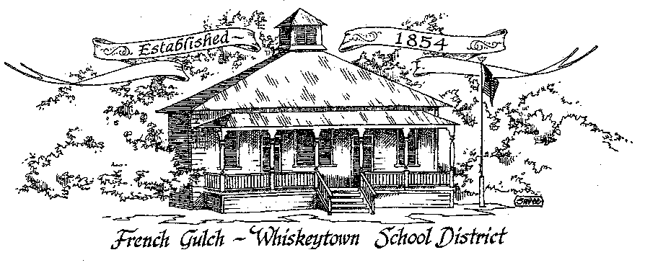

Successful students today – Successful citizen’s tomorrow

French Gulch-Whiskeytown School District
11442 Cline Gulch Rd., French Gulch, CA 96033
530-359-2151

REGULAR MEETING OF THE GOVERNING BOARD
Minutes

June 17, 2022 5:00 PM

OUR DISTRICT MISSION
The French Gulch-Whiskeytown School District is dedicated to building resourceful, respectful, academically strong individuals.
CALL TO ORDER & OPEN SESSION
5:00 PM

1. CALL TO ORDER
ROLL CALL
Heather VanHorn, President ☒ Lesley Pearson, Clerk ☒
Keli Laws ☐ ☐ Sara Wells ☐ Crystal Andersen X
2. OPPORTUNITY FOR PUBLIC COMMENT ON AGENDA ITEMS

Public Comment on any item of interest to the public that is within the Board’s jurisdiction will be heard. The Board may limit comments to no more than 3 minutes pursuant to Board policy. Public comment will also be allowed on each specific agenda.

3. APPROVAL OF AGENDA -
1st: Lesley Pearson 2nd: Crystal Andersen Ayes: All Nays: None
4. CORRESPONDENCE –
4.1 LETTER FROM JACK SCHREDER & ASSOCIATES, INC
Jack passed and his daughter sent a very nice letter to all of his clients, which Moira shared
5. APPROVAL OF MINUTES-
5.1 APPROVE MINUTES OF MAY 17, 2022 REGULAR BOARD MEETING- June 20 Meeting
5.2 APPROVE MINUTES OF APRIL 19, 2022 REGULAR BOARD MEETING- June 20 Meeting

6. REPORTS AND PUBLIC FORUM (if applicable)
6.1 SUPERINTENDENT REPORT-
a. Summer School
Small group of about 6 kids. We are providing lunch to SS and to the Community to anyone under 18. Meal must be served at school
b. Progress of Superintendent, Lower Elementary instructor, classroom aides search
We are still in search of potential teachers and aides. Moira and Cindy Gonzalez will split the 22-23 School year. Position is posted at Simpson college and Moira threw it out to the Board if we want to use Enjoin.
c. Summer projects, install hoods in kitchen, irrigation repair, paint touch up
Irrigation was fixed this week, the kitchen hoods will be installed and Donna may do some touch up paint around the school
d. Reading intervention specialist
Carol Wertz is a reading specialist who comes from Simpson college. She will be working to help with K-4 reading group.

e. Volunteer and Parent transportation policy
It is suggested from the insurance company that we have a policy for Volunteers that asks for fingerprints before they can volunteer. Also we are to come up with policies for using school van
f. Relevant Updates

7. DISCUSSION ITEMS and/or PUBLIC HEARING (if applicable)
PUBLIC FORUM HEARING OF PERSONS WISHING TO ADDRESS THE BOARD

7.1 PRESENTATION OF THE 2022-2023 PROPOSED BUDGET
7.2 PRESENTATION OF THE EXCESS RESERVES DISCLOSURE
7.3 PRESENTATION OF THE 22-23 EPA DISCLOSURE
7.4 3 YEAR BUDGET PROJECTION
7.5 2022-23 LCAP DRAFT PRESENTATION
7.6 ANNUAL UPDATE ON 2021-2022 LCAP

ACTION ITEMS –

8.1 APPROVAL OF WARRANTS FOR MAY 18, 2022 to JUNE 13, 2022
1st: Crystal Andersen 2nd: Lesley Pearson Ayes: All Nays: None
8.2 APPROVAL OF APRIL 1, 2022 – JUNE 30, 2022 QUARTERLY REPORT ON WILLIAMS UNIFORM COMPLAINTS- ZERO COMPLAINTS
1st: Crystal Andersen 2nd: Lesley Pearson Ayes: All Nays: None
8.3 APPROVAL OF RESOLUTION 1-22-23 FGWS EDUCATION PROTECTION ACCOUNT
1st: Crystal Andersen 2nd: Lesley Pearson Ayes: All Nays: None
8.4 APPROVAL OF RESOLUTION #18-22-23 that Provides for Classification of Fund Balances in the General Fund and is Compliant with Governmental Accounting Standards Board (GASB) Statement 54
1st: Crystal Andersen 2nd: Lesley Pearson Ayes: All Nays: None
8.5 APPROVAL OF RESOLUTION #19-22-23 ESTABLISHING REVOLVING CASH FUNDS FOR THE 2022-2023 FISCAL YEAR
1st: Crystal Andersen 2nd: Lesley Pearson Ayes: All Nays: None
8.6 APPROVAL OF RESOLUTION #20-22-23 AUTHORIZING THE COUNTY SUPERINTENDENT OF SCHOOLS AND COUNTY AUDITOR TO SIGN SEPARATE PAYROLL WARRANTS IN THE NAMES OF INDIVIDUAL DISTRICT EMPLOYEES FOR THE 2022-2023 FISCAL YEAR
1st: Crystal Andersen 2nd: Lesley Pearson Ayes: All Nays: None
8.7 APPROVAL OF RESOLUTION #21-22-23 DELEGATING 2022-2023 TRAVEL AUTHORIZATION FOR EMPLOYEES TO THE SUPERINTENDENT
1st: Crystal Andersen 2nd: Lesley Pearson Ayes: All Nays: None
8.8 APPROVAL OF RESOLUTION #22-22-23 AUTHORIZING 2022-2023 TRAVEL OF MEMBERS OF THE GOVERNING BOARD
1st: Crystal Andersen 2nd: Lesley Pearson Ayes: All Nays: None
8.9 APPROVAL OF RESOLUTION #23-22-23 AUTHORIZING THE SUPERINTENDENT AND THE SHASTA COUNTY OFFICE OF EDUCATION (SCOE) DIRECTOR OF BUSINESS SERVICES TO SIGN COMMERCIAL WARRANTS
1st: Crystal Andersen 2nd: Lesley Pearson Ayes: All Nays: None
8.10 APPROVAL OF RESOLUTION #24-22-23 AUTHORIZING THE ASSISTANT SUPERINTENDENT OF BUSINESS SERVICES TO MAKE BUDGET REVISIONS FOR THE 2022-2023 FISCAL YEAR
1st: Crystal Andersen 2nd: Lesley Pearson Ayes: All Nays: None
8.11 APPROVAL OF RESOLUTION #25-22-23 AUTHORIZING THE SUPERINTENDENT OR DESIGNEE TO TRANSFER EXPENDITURES AND/OR REVENUES BETWEEN FUNDS FOR THE 2022-2023 FISCAL YEAR
1st: Crystal Andersen 2nd: Lesley Pearson Ayes: All Nays: None
8.12 PREAPPROVE THE CONAPP
1st: Crystal Andersen 2nd: Lesley Pearson Ayes: All Nays: None
8.13 APPROVAL OF THE MAY 2022 AMENDMENT TO NORTHERN CALIFORNIA SCHOOLS INSURANCE GROUP BYLAWS
1st: Crystal Andersen 2nd: Lesley Pearson Ayes: All Nays: None

PLANNING-
9.1 ITEMS FROM THE FLOOR: Comments, Suggestions for future meetings, etc.
9.2 Next Meeting of the Board: June 20, 2022 Special Meeting at 5:00pm

10. ADJOURNMENT-
10.1 Adjourn Meeting

In compliance with the Americans with Disabilities Act, the French Gulch-Whiskeytown School District will make available to any member of the public who has a disability, appropriate disability-related modifications or accommodations in order for that person to participate in the public meeting. Contact Kristin George in the Office of the Superintendent, French Gulch-Whiskeytown School District Office, 11442 Cline Gulch Rd., French Gulch, California, at (530) 359-2151 at least 48 hours prior to the scheduled meeting. We will make every effort to give primary consideration to expressed preferences, or provide equally effective means of communication to ensure equal access to French Gulch-Whiskeytown School District public meetings.
All documents presented to the members of the Governing Board for consideration at this meeting are included in this agenda packet. Documents unavailable at the time of the printing of this agenda are available for public review in the District Office, 11442 Cline Gulch Rd, during regular business hours. The public is invited and encouraged to attend and participate in Board Meetings. Persons wishing to address the Board may do so during the Opportunity for Public Comment. Speakers are limited to three minutes each. Other opportunities to address the Board include the Public Forum and Items from the Floor. By law, the Board is not allowed to take action on matters that are not on the agenda.

