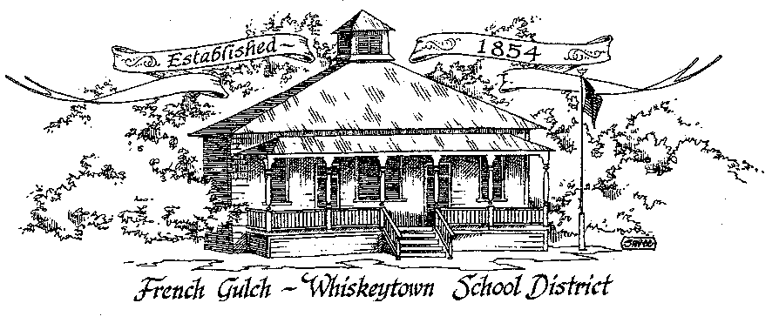

Successful students today – Successful citizen’s tomorrow

French Gulch-Whiskeytown School District
11442 Cline Gulch Rd., French Gulch, CA 96033
530-359-2151

REGULAR MEETING OF THE GOVERNING BOARD

June 14, 2021 5:00 PM

MINUTES

OUR DISTRICT MISSION
The French Gulch-Whiskeytown School District is dedicated to building resourceful, respectful, academically strong individuals.
CALL TO ORDER & OPEN SESSION
5:00 PM

1. CALL TO ORDER
ROLL CALL
Heather VanHorn, President ☒ Lesley Pearson, Clerk ☒
Matthew Balch ☐ ☒ Sara Wells ☒ Crystal Andersen x
2. OPPORTUNITY FOR PUBLIC COMMENT ON AGENDA ITEMS

Public Comment on any item of interest to the public that is within the Board’s jurisdiction will be heard. The Board may limit comments to no more than 3 minutes pursuant to Board policy. Public comment will also be allowed on each specific agenda.

3. APPROVAL OF AGENDA -
1st: Sara Wells 2nd: Crystal Anderson Ayes: All
4. CORRESPONDENCE –
4.1 LETTERS FROM THE SHASTA CO WATER AGENCY
4.2 LETTER FROM HORTON MCNULTY & SAETURN ON AUDIT PLANNING

5. APPROVAL OF MINUTES-
5.1 APPROVE MINUTES OF MAY 12, 2021 SPECIAL BOARD MEETING
Moved to be approved at the June 16, 2021 Special Meeting

6. REPORTS AND PUBLIC FORUM (if applicable)
6.1 SUPERINTENDENT REPORT-
a. ADA FOR 2020-2021
The ADA for 20-21 is 27, which is funding band 2. Even though that is not a bad ADA for us, the Covid Safe Harbor that is in place to protect other schools, has a negative impact on us, a micro small school.
b. REPORT OUT ON THE GRADUATION/MOVING UP EVENT
This was our second, Covid inspired, Graduation Caravan through French Gulch. We stopped at the homes of the graduates on Main Street, including the SHS graduates. Families gathered at the Post Office, and we went through the Park. We had cakes, balloons, ceramic and glass gifts from Miss B, and honked horns and cheered them all on. Very sweet. Joz and Alex were interviewed by the Record Searchlight.
c. SUMMER SCHOOL/SHARE PROGRAM
Summer school is on session and going well. June 7th to July 2nd are the running dates. The teacher is Linda, with Bob doing some STEM and building with the 2-8 students. Emily is tutoring and teaching a movie making class. Kristin is cooking lunch. SHARE immediately follows and runs until 5:30pm.

d. STAFFING 2021-22
Sadly, Miss B retired, hoping to see her doing some Ceramics in the 21-22 School year.
Linda is still deciding if she is coming back or not.
Renay is looking to move from 4/5ths to 3/5ths,
e. TITLE I STATUS
After all the paperwork, based in the 2010 Census, FGWS will receive no monies.
f. REVISION OF 2021-22 CALENDAR

We are proposing that in order for the teachers to attend an important writing workshop on Monday August 16th, that we start school on Tuesday August 17th.
We would make that day up on September 12th, the day after Veteran’s Day. Shasta Union has Friday the 12th off.

7. DISCUSSION ITEMS and/or PUBLIC HEARING (if applicable)
PUBLIC FORUM HEARING OF PERSONS WISHING TO ADDRESS THE BOARD

7.1 PRESENTATION OF THE 2021-2022 PROPOSED BUDGET
7.2 PRESENTATION OF THE EXCESS RESERVES DISCLOSURE
7.3 PRESENTATION OF THE 21-22 EPA DISCLOSURE
7.4 3 YEAR BUDGET PROJECTION
7.5 2021-22 LCAP DRAFT PRESENTATION
7.6 ANNUAL UPDATE ON 2019-20 LCAP
7.7 TITLE IX POLICY REQUIREMENTS
7.8 PREAPPROVAL OF THE CONAPP

ACTION ITEMS –

8.1 APPROVAL OF WARRANTS FOR MAY 11, 2021 to JUNE 11, 2021
1st: Lesley Pearson 2nd: Sara Wells Ayes: All
8.2 APPROVAL OF APRIL 1, 2021 – JUNE 30, 2021 QUARTERLY REPORT ON WILLIAMS UNIFORM COMPLAINTS- ZERO COMPLAINTS
1st: Lesley Pearson 2nd: Sara Wells Ayes: All
8.3 APPROVAL OF RESOLUTION 1-21-22 FGWS EDUCATION PROTECTION ACCOUNT
1st: Lesley Pearson 2nd: Sara Wells Ayes: All

8.4 APPROVAL OF RESOLUTION #18-21-22 that Provides for Classification of Fund Balances in the General Fund and is Compliant with Governmental Accounting Standards Board (GASB) Statement 54
1st: Lesley Pearson 2nd: Sara Wells Ayes: All
8.5 APPROVAL OF RESOLUTION #19-21-22 ESTABLISHING REVOLVING CASH FUNDS FOR THE 2021-2022 FISCAL YEAR
1st: Lesley Pearson 2nd: Sara Wells Ayes: All
8.6 APPROVAL OF RESOLUTION #20-21-22 AUTHORIZING THE COUNTY SUPERINTENDENT OF SCHOOLS AND COUNTY AUDITOR TO SIGN SEPARATE PAYROLL WARRANTS IN THE NAMES OF INDIVIDUAL DISTRICT EMPLOYEES FOR THE 2021-2022 FISCAL YEAR
1st: Lesley Pearson 2nd: Sara Wells Ayes: All
8.7 APPROVAL OF RESOULTION #21-21-22 DELEGATING 2021-2022 TRAVEL AUTHORIZATION FOR EMPLOYEES TO THE SUPERINTENDENT
1st: Lesley Pearson 2nd: Sara Wells Ayes: All
8.8 APPROVAL OF RESOULTION #22-21-22 AUTHORIZING 2021-2022 TRAVEL OF MEMBERS OF THE GOVERNING BOARD
1st: Lesley Pearson 2nd: Sara Wells Ayes: All

8.9 APPROVAL OF RESOLUTION #23-21-22 AUTHORIZING THE SUPERINTENDENT AND THE SHASTA COUNTY OFFICE OF EDUCATION (SCOE) DIRECTOR OF BUSINESS SERVICES TO SIGN COMMERCIAL WARRANTS
1st: Lesley Pearson 2nd: Sara Wells Ayes: All
8.10 APPROVAL OF RESOLUTION #24-21-22 AUTHORIZING THE ASSISTANT SUPERINTENDENT OF BUSINESS SERVICES TO MAKE BUDGET REVISIONS FOR THE 2021-2022 FISCAL YEAR
1st: Lesley Pearson 2nd: Sara Wells Ayes: All
8.11 APPROVAL OF RESOULTION #25-21-22 AUTHORIZING THE SUPERINTENDENT OR DESIGNEE TO TRANSFER EXPENDITURES AND/OR REVENUES BETWEEN FUNDS FOR THE 2021-2022 FISCAL YEAR
1st: Lesley Pearson 2nd: Sara Wells Ayes: All
8.12 APPROVAL OF COMPENSATION FOR SPEECH AND LANGUAGE SERVICES FOR MOIRA CASEY FOR THE 2020-2021 SCHOOL YEAR
1st: Lesley Pearson 2nd: Sara Wells Ayes: All
8.13 APPROVAL OF THE REVISED CALENDAR FOR THE 2021-22 SCHOOL YEAR
1st: Lesley Pearson 2nd: Sara Wells Ayes: All
8.14 PREAPPROVE THE CONAPP
1st: Lesley Pearson 2nd: Sara Wells Ayes: All

PLANNING-
9.1 ITEMS FROM THE FLOOR: Comments, Suggestions for future meetings, etc.
9.2 Next Meeting of the Board: June 16 Special Meeting at 5:00pm

10. ADJOURNMENT-
10.1 Adjourn Meeting

In compliance with the Americans with Disabilities Act, the French Gulch-Whiskeytown School District will make available to any member of the public who has a disability, appropriate disability-related modifications or accommodations in order for that person to participate in the public meeting. Contact Kristin George in the Office of the Superintendent, French Gulch-Whiskeytown School District Office, 11442 Cline Gulch Rd., French Gulch, California, at (530) 359-2151 at least 48 hours prior to the scheduled meeting. We will make every effort to give primary consideration to expressed preferences, or provide equally effective means of communication to ensure equal access to French Gulch-Whiskeytown School District public meetings.
All documents presented to the members of the Governing Board for consideration at this meeting are included in this agenda packet. Documents unavailable at the time of the printing of this agenda are available for public review in the District Office, 11442 Cline Gulch Rd, during regular business hours. The public is invited and encouraged to attend and participate in Board Meetings. Persons wishing to address the Board may do so during the Opportunity for Public Comment. Speakers are limited to three minutes each. Other opportunities to address the Board include the Public Forum and Items from the Floor. By law, the

