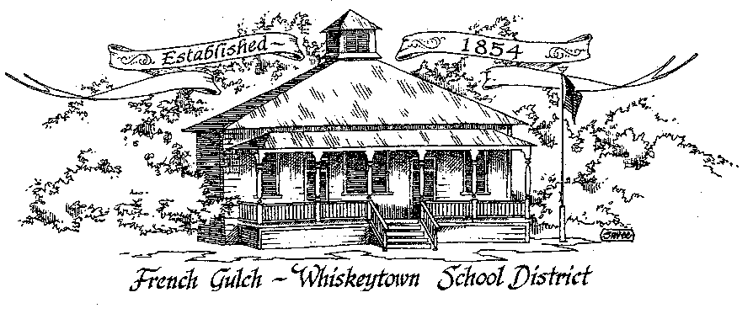

French Gulch-Whiskeytown School District
11442 Cline Gulch Rd., French Gulch, CA 96033
530-359-2151

REGULAR MEETING OF THE GOVERNING BOARD
MINUTES

January 18, 2022 5:00 PM

OUR DISTRICT MISSION
The French Gulch-Whiskeytown School District is dedicated to building resourceful, respectful, academically strong individuals.
CALL TO ORDER & OPEN SESSION
5:00 PM

1. CALL TO ORDER
ROLL CALL
Heather VanHorn, President ☒ Lesley Pearson, Clerk ☒
Sara Wells ☒ Crystal Anderson ☒

2. OPPORTUNITY FOR PUBLIC COMMENT ON AGENDA ITEMS

Public Comment on any item of interest to the public that is within the Board’s jurisdiction will be heard. The Board may limit comments to no more than 3 minutes pursuant to Board policy. Public comment will also be allowed on each specific agenda.

3. APPROVAL OF AGENDA -
1st: Sara Wells 2nd: Lesley Pearson Ayes: All Nays: None
4. CORRESPONDENCE –

5. APPROVAL OF MINUTES-
5.1 APPROVE MINUTES OF DECEMBER 14, 2021 ORGANIZATIONAL BOARD MEETING
1st: Sara Wells 2nd: Lesley Pearson Ayes: All Nays: None
6. REPORTS AND PUBLIC FORUM (if applicable)
6.1 SUPERINTENDENT REPORT:
a. Enrollment (27)
b. Funding Band for 2022-23/Saturday School (P1 24.25)
c. Update on Covid-19 precautions/practices at school
d. Participation in the Great Kindness Campaign
e. Jump Rope for Heart

7. DISCUSSION ITEMS and/or PUBLIC HEARING (if applicable)
7.1 LCAP spending to date
7.2 Emergency Operations Plan Review
7.3 SARC Report- any changes prior to approval
7.4 Possibility of Project SHARE operating on winter and spring breaks
7.5 Executive Order N-3-22 from governor Newsom’ s office regarding flexibility changes for substitute teacher requirements to assist in covering short term staffing needs for in-person Instruction during the Omicron surge

8. ACTION ITEMS –

8.1 APPROVAL OF THE 20-21 ANNUAL DEVELOPER FEE REPORT & CAPITAL FACILITY FUND REPORT
1st: Sara Wells 2nd: Crystal Andersen, Ayes: All Nays: None
8.2 APPROVAL OF THE WARRANTS: 12/16/2021-1/14/2021
1st: Sara Wells 2nd: Crystal Andersen, Ayes: All Nays: None
8.3 APPROVAL OF QUARTERLY REPORT ON “WILLIAMS UNIFORM COMPLAINTS” OCTOBER 1, 2021 to DECEMBER 31, 2021
1st: Sara Wells 2nd: Crystal Andersen, Ayes: All Nays: None
8.4 APPROVAL OF THE SCHOOL ACCOUNTABILITY REPORT CARD (SARC)
1st: Sara Wells 2nd: Crystal Andersen, Ayes: All Nays: None
8.5 APPROVAL OF $14.00 MIMIMUM WAGE ON CLASSIFIED SALARY SCHEDULE
1st: Sara Wells 2nd: Crystal Andersen, Ayes: All Nays: None
8.6 APPROVAL FOR PARTICIPATION IN THE GAS THE ELECTRIC LAWN TOOL REBATE PROGRAM
1st: Sara Wells 2nd: Crystal Andersen, Ayes: Heather VanHorn Nays: Lesley Pearson

9. PLANNING-
9.1 ITEMS FROM THE FLOOR: Comments, Suggestions for future meetings, etc.
9.2 Next Meeting of the Board: February 15, 2021, 5:00 PM
9.3 OTHER IMPORTANT DATES
- JUMP ROPE FOR HEART – FEBRUARY 14
- WINTER BREAK - FEBRUARY 21 TO 25

10. ADJOURNMENT
10.1 Adjourn Meeting

In compliance with the Americans with Disabilities Act, the French Gulch-Whiskeytown School District will make available to any member of the public who has a disability, appropriate disability-related modifications or accommodations in order for that person to participate in the public meeting. Contact Kristin George in the Office of the Superintendent, French Gulch-Whiskeytown School District Office, 11442 Cline Gulch Rd., French Gulch, California, at (530) 359-2151 at least 48 hours prior to the scheduled meeting. We will make every effort to give primary consideration to expressed preferences, or provide equally effective means of communication to ensure equal access to French Gulch-Whiskeytown School District public meetings.
All documents presented to the members of the Governing Board for consideration at this meeting are included in this agenda packet. Documents unavailable at the time of the printing of this agenda are available for public review in the District Office, 11442 Cline Gulch Rd, during regular business hours. The public is invited and encouraged to attend and participate in Board Meetings. Persons wishing to address the Board may do so during the Opportunity for Public Comment. Speakers are limited to three minutes each. Other opportunities to address the Board include the Public Forum and Items from the Floor. By law, the Board is not allowed to take action on matters that are not on the a

