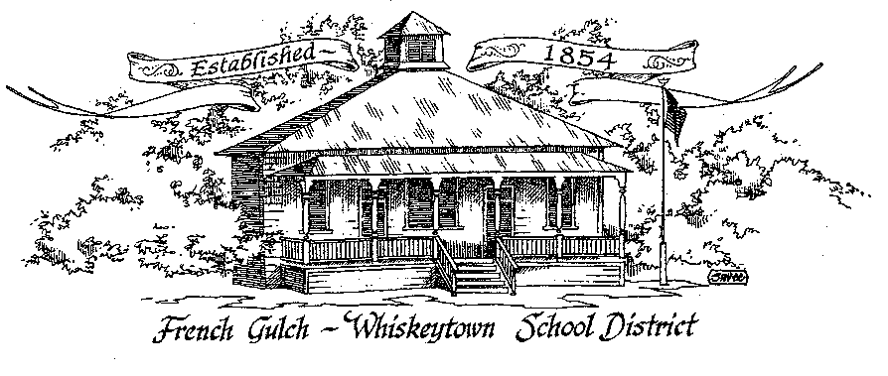

French Gulch-Whiskeytown School District
11442 Cline Gulch Rd., French Gulch, CA 96033
530-359-2151

MINUTES

REGULAR MEETING OF THE GOVERNING BOARD

January 17, 2023 5:00 PM

OUR DISTRICT MISSION
The French Gulch-Whiskeytown School District is dedicated to building resourceful, respectful, academically strong individuals.
CALL TO ORDER & OPEN SESSION
5:00 PM

1. CALL TO ORDER 5:16
ROLL CALL
Heather VanHorn, President ☐x Lesley Pearson, Clerk ☐x Keli Laws ☐
Sara Wells ☐x Crystal Anderson ☐x

2. OPPORTUNITY FOR PUBLIC COMMENT ON AGENDA ITEMS

Public Comment on any item of interest to the public that is within the Board’s jurisdiction will be heard. The Board may limit comments to no more than 3 minutes pursuant to Board policy. Public comment will also be allowed on each specific agenda.

3. APPROVAL OF AGENDA - addendum to superintendent’s report : relevant updates
Agenda with addendum added moved by Sara Wells, seconded by Crystal Andersen
ayes 3 nays 0

4. CORRESPONDENCE –
4.1 AMY BARKER EMAIL ON BROWN ACT CHANGES
Amy Barker sent an email addressing changes to agendas as per changes to the Brown Act: items not posted 72 hours in advance of the meeting to board members must be made available to the public for inspection at the same time they are distributed to the board. This change can be made available through use of the LEA website if it meets 4 criteria.

4.2 LETTER FROM THE AUDITOR, HORTON MCNULTY & SAETEURN
HM&S sent a statement regarding their recent audit of the district’s records ending in June, 2022. There was one understatement of $2358 which has been rectified.

5. APPROVAL OF MINUTES-
5.1 APPROVE MINUTES OF DECEMBER 20, 2022 ORGANIZATIONAL BOARD MEETING
Deferred until February due to board representation at the January meeting.
6. REPORTS AND PUBLIC FORUM (if applicable)
6.1 SUPERINTENDENT REPORT:
a. January 2023 Enrollment (21)
Inching up tp the second funding band but not their yet
b. Funding Band for 2023-24/Saturday School
Will check with the accountant to see if we can “preemptively” hold Saturday school sessions to make up attendance. Throughout out November and December, attempted to mitigate excessive absences through independent study.
c. Kristin resigning, search for new employee (s)
Kristin’s position will be posted. Two options: 1 full time position to cover both office manager and cafeteria (currently Kristin’s position) or two part time positions: office manager and cafeteria manager
d. Relevant Update
Incident of vandalism presumably yesterday (1-17-23). Large window in the boys’ bathroom. Sheriff, insurance and Moule’s glass all notified and reports filed Replacement will be around $700. This does not meet the $5000 deductible for insurance. The Sheriff’s office issued an incident report case number. Vandalism perpetrators remain unknown at this time.
Cindy Gonzales was unable to make the meeting and extended her apologies. A family emergency needed to be addressed. Cindy sent her regards to the board.
7. DISCUSSION ITEMS and/or PUBLIC HEARING (if applicable)
7.1 LCAP spending to date
Spending changes due to several staffing issues but within the allotted funds
7.2 Emergency Operations Plan Review
Cindy Gonzalez has been working on the Safety Plan. Her goal is to update and streamline the current plan.
7.3 SARC Report- any changes prior to approval
The SARC plan has been updated and edited to showcase the most current information on FGWS.

8. ACTION ITEMS –

8.1 APPROVAL OF THE 21-22 ANNUAL DEVELOPER FEE REPORT & CAPITAL FACILITY FUND REPORT
8.2 APPROVAL OF THE WARRANTS: 12/21/2022-1/13/2023
8.3 APPROVAL OF QUARTERLY REPORT ON “WILLIAMS UNIFORM COMPLAINTS” OCTOBER 1, 2022 to DECEMBER 31, 2022
8.4 APPROVAL OF THE SCHOOL ACCOUNTABILITY REPORT CARD (SARC)
Sara moved to approve the action items as a block consent agenda item, seconded by Crystal ayes 3 nays 0

9. PLANNING-
9.1 ITEMS FROM THE FLOOR: Comments, Suggestions for future meetings, etc.
9.2 Next Meeting of the Board: February 21, 2023, 5pm
9.3 OTHER IMPORTANT DATES
- WINTER BREAK - FEBRUARY 20 TO 24

10. ADJOURNMENT
10.1 Adjourn Meeting 5:45

In compliance with the Americans with Disabilities Act, the French Gulch-Whiskeytown School District will make available to any member of the public who has a disability, appropriate disability-related modifications or accommodations in order for that person to participate in the public meeting. Contact Kristin George in the Office of the Superintendent, French Gulch-Whiskeytown School District Office, 11442 Cline Gulch Rd., French Gulch, California, at (530) 359-2151 at least 48 hours prior to the scheduled meeting. We will make every effort to give primary consideration to expressed preferences, or provide equally effective means of communication to ensure equal access to French Gulch-Whiskeytown School District public meetings.
All documents presented to the members of the Governing Board for consideration at this meeting are included in this agenda packet. Documents unavailable at the time of the printing of this agenda are available for public review in the District Office, 11442 Cline Gulch Rd, during regular business hours. The public is invited and encouraged to attend and participate in Board Meetings. Persons wishing to address the Board may do so during the Opportunity for Public Comment. Speakers are limited to three minutes each. Other opportunities to address the Board include the Public Forum and Items from the Floor. By law, the Board is not allowed to take action on matters that are not on the

