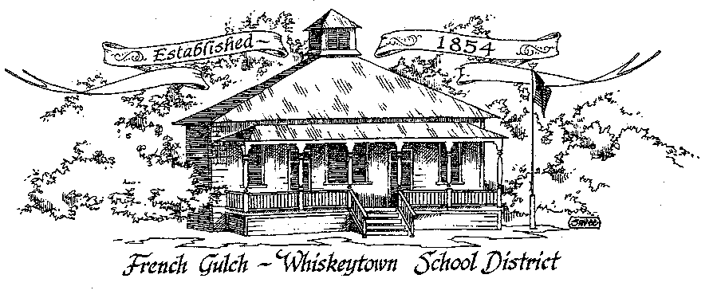

French Gulch-Whiskeytown School District
11442 Cline Gulch Rd., French Gulch, CA 96033
530-359-2151

REGULAR MEETING OF THE GOVERNING BOARD

January 17, 2023 5:00 PM

OUR DISTRICT MISSION
The French Gulch-Whiskeytown School District is dedicated to building resourceful, respectful, academically strong individuals.
CALL TO ORDER & OPEN SESSION
5:00 PM

1. CALL TO ORDER
ROLL CALL
Heather VanHorn, President ☐ Lesley Pearson, Clerk ☐ Keli Laws ☐
Sara Wells ☐ Crystal Anderson ☐

2. OPPORTUNITY FOR PUBLIC COMMENT ON AGENDA ITEMS

Public Comment on any item of interest to the public that is within the Board’s jurisdiction will be heard. The Board may limit comments to no more than 3 minutes pursuant to Board policy. Public comment will also be allowed on each specific agenda.

3. APPROVAL OF AGENDA -

4. CORRESPONDENCE –
4.1 AMY BARKER EMAIL ON BROWN ACT CHANGES
4.2 LETTER FROM THE AUDITOR, HORTON MCNULTY & SAETEURN

5. APPROVAL OF MINUTES-
5.1 APPROVE MINUTES OF DECEMBER 20, 2022 ORGANIZATIONAL BOARD MEETING

6. REPORTS AND PUBLIC FORUM (if applicable)
6.1 SUPERINTENDENT REPORT:
a. January 2023 Enrollment (21)
b. Funding Band for 2023-24/Saturday School
c. Kristin resigning, search for new employee (s)

7. DISCUSSION ITEMS and/or PUBLIC HEARING (if applicable)
7.1 LCAP spending to date
7.2 Emergency Operations Plan Review
7.3 SARC Report- any changes prior to approval

8. ACTION ITEMS –

8.1 APPROVAL OF THE 21-22 ANNUAL DEVELOPER FEE REPORT & CAPITAL FACILITY FUND REPORT
8.2 APPROVAL OF THE WARRANTS: 12/21/2022-1/13/2023
8.3 APPROVAL OF QUARTERLY REPORT ON “WILLIAMS UNIFORM COMPLAINTS” OCTOBER 1, 2022 to DECEMBER 31, 2022
8.4 APPROVAL OF THE SCHOOL ACCOUNTABILITY REPORT CARD (SARC)

9. PLANNING-
9.1 ITEMS FROM THE FLOOR: Comments, Suggestions for future meetings, etc.
9.2 Next Meeting of the Board: February 21, 2023, 5pm
9.3 OTHER IMPORTANT DATES
- WINTER BREAK - FEBRUARY 20 TO 24

10. ADJOURNMENT
10.1 Adjourn Meeting

In compliance with the Americans with Disabilities Act, the French Gulch-Whiskeytown School District will make available to any member of the public who has a disability, appropriate disability-related modifications or accommodations in order for that person to participate in the public meeting. Contact Kristin George in the Office of the Superintendent, French Gulch-Whiskeytown School District Office, 11442 Cline Gulch Rd., French Gulch, California, at (530) 359-2151 at least 48 hours prior to the scheduled meeting. We will make every effort to give primary consideration to expressed preferences, or provide equally effective means of communication to ensure equal access to French Gulch-Whiskeytown School District public meetings.
All documents presented to the members of the Governing Board for consideration at this meeting are included in this agenda packet. Documents unavailable at the time of the printing of this agenda are available for public review in the District Office, 11442 Cline Gulch Rd, during regular business hours. The public is invited and encouraged to attend and participate in Board Meetings. Persons wishing to address the Board may do so during the Opportunity for Public Comment. Speakers are limited to three minutes each. Other opportunities to address the Board include the Public Forum and Items from the Floor. By law, the Board is not allowed to take action on matters that are not on the a

