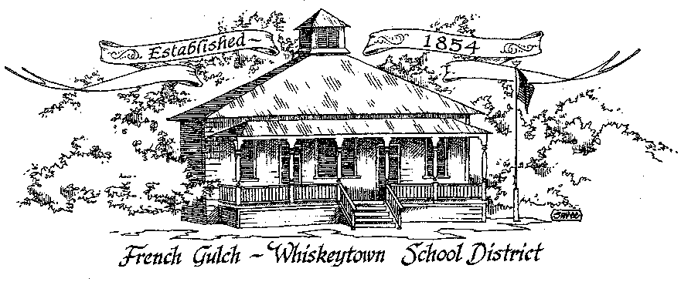

French Gulch-Whiskeytown School District
11442 Cline Gulch Rd., French Gulch, CA 96033
530-359-2151

REGULAR MEETING OF THE GOVERNING BOARD

February 15, 2022 5:00 PM
MINUTES

OUR DISTRICT MISSION
The French Gulch-Whiskeytown School District is dedicated to building resourceful, respectful, academically strong individuals.
CALL TO ORDER & OPEN SESSION
5:00 PM

1. CALL TO ORDER
ROLL CALL
Heather VanHorn, President ☐ Lesley Pearson, Clerk ☒
Crystal Andersen ☒ Sara Wells ☒
2. OPPORTUNITY FOR PUBLIC COMMENT ON AGENDA ITEMS

Public Comment on any item of interest to the public that is within the Board’s jurisdiction will be heard. The Board may limit comments to no more than 3 minutes pursuant to Board policy. Public comment will also be allowed on each specific agenda.

3. APPROVAL OF AGENDA:
1st: Sara Wells 2nd: Crystal Andersen Ayes: All Nays: None

4. CORRESPONDENCE:
4.1 LETTER FROM SCOE REGARDING FIRST INTERIM BUDGET
4.2 LETTER FROM SCOE REGARDING MOUNTAIN VALLEY JPA BUDGET
4.3 LETTER FROM HORTON MCNULTY & SAETURN REGARDING AUDIT FINDINGS

5. APPROVAL OF MINUTES:
5.1 APPROVE MINUTES OF THE JANUARY 18, 2022 BOARD MEETING
1st: Sara Wells 2nd: Crystal Andersen Ayes: All Nays: None

6. REPORTS AND PUBLIC FORUM: (if applicable)
6.1 SUPERINTENDENT REPORT:
a. CDPH RESPONSE TO SUPERINTENDENTS’ LETTER ON COVID
A letter on Covid Vax for kids essentially saying that mandate will come and umbrella-ed under AB277
b. MARCH SATURDAY SCHOOLS
We will hold Saturday School March 5th, 12th and 19th, lunch will be served We are off by .25 again.
c. COVID OUTBREAK AT FGWS
Lots of positive tests and absences
d. ADA is 26
e. SHASTA COUNTY SUPERINTENDENTS’ LETTER REGARDING BILL 841

7. DISCUSSION ITEMS and/or PUBLIC HEARING (if applicable)
7.1 LCAP MID YEAR REPORT
7.2 STUDENT/PARENT SURVEY RESULTS
7.3 KELI LAWS
7.4 SPEECH LANGUAGE SERVICES AT FGWS

8. ACTION ITEMS:

8.1 APPROVAL OF WARRANTS 1/19/2022 THROUGH 2/14/2022
1st: Sara Wells 2nd: Crystal Andersen Ayes: All Nays: None
8.2 APPROVAL OF THE FGWS EMERGENCY OPERATIONS PROCEDURE HANDBOOK
1st: Sara Wells 2nd: Crystal Andersen Ayes: All Nays: None
8..3 APPROVAL OF KELI LAWS APPOINTMENT TO THE BOARD
1st: Sara Wells 2nd: Crystal Andersen Ayes: All Nays: None

9. PLANNING:

9.1 ITEMS FROM THE FLOOR: Comments, Suggestions for future meetings, etc.
9.2 Next Meeting of the Board: MARCH 15, 2022 at 5:00 pm
9.3 OTHER IMPORTANT DATES:
- FEBRUARY 21 TO 25: WINTER BREAK
- FEBRUARY 28: 2ND TRI MESTER ENDS

10. ADJOURNMENT:
10.1 Adjourn Meeting

In compliance with the Americans with Disabilities Act, the French Gulch-Whiskeytown School District will make available to any member of the public who has a disability, appropriate disability-related modifications or accommodations in order for that person to participate in the public meeting. Contact Kristin George in the Office of the Superintendent, French Gulch-Whiskeytown School District Office, 11442 Cline Gulch Rd., French Gulch, California, at (530) 359-2151 at least 48 hours prior to the scheduled meeting. We will make every effort to give primary consideration to expressed preferences, or provide equally effective means of communication to ensure equal access to French Gulch-Whiskeytown School District public meetings.
All documents presented to the members of the Governing Board for consideration at this meeting are included in this agenda packet. Documents unavailable at the time of the printing of this agenda are available for public review in the District Office, 11442 Cline Gulch Rd, during regular business hours. The public is invited and encouraged to attend and participate in Board Meetings. Persons wishing to address the Board may do so during the Opportunity for Public Comment. Speakers are limited to three minutes each. Other opportunities to address the Board include the Public Forum and Items from the Floor. By law, the Board is not allowed to take action on matters that are not on the agenda.

