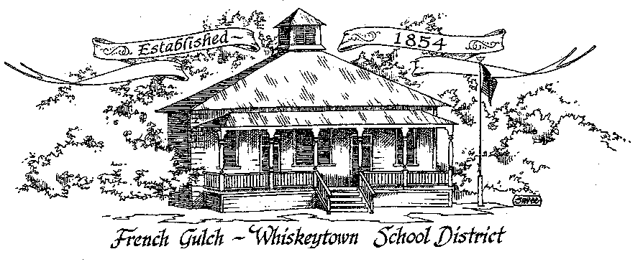

French Gulch-Whiskeytown School District
11442 Cline Gulch Rd., French Gulch, CA 96033
530-359-2151

ANNUAL ORGANIZATIONAL MEETING OF THE GOVERNING BOARD

December 20, 2022 5:00 PM

OUR DISTRICT MISSION
The French Gulch-Whiskeytown School District is dedicated to building resourceful, respectful, academically strong individuals.
CALL TO ORDER & OPEN SESSION
5:00 PM

1. CALL TO ORDER
ROLL CALL
Heather VanHorn, President ☐ Lesley Pearson, Clerk ☐
Keli Laws ☐ Sara Wells ☐ Crystal Andersen €

2. OPPORTUNITY FOR PUBLIC COMMENT ON AGENDA ITEMS

Public Comment on any item of interest to the public that is within the Board’s jurisdiction will be heard. The Board may limit comments to no more than 3 minutes pursuant to Board policy. Public comment will also be allowed on each specific agenda.

3. APPROVAL OF AGENDA:

4. CORRESPONDENCE:
4.1 MEMORANDUM FROM STSIG ON CERTIFICATE OF WORKERS COMPENSATION
4.2 CALIFORNIA STATE CONTROLLER OFFICE NOTIFICATION OF NEW DATA
PORTAL FOR GOVERNMENT COMPENSATION IN CALIFORNATION REPORT
SUBMISSIONS

5. APPROVAL OF MINUTES:
5.1 APPROVE MINUTES OF THE NOVEMBER 15 2022 BOARD MEETING

6. REPORTS AND PUBLIC FORUM (if applicable)
6.1 SUPERINTENDENT REPORT:
a. December attendance/enrollment
b. School/Holiday Evening
c. Ongoing Search for certificated instructor update
d. Music teacher update
e. clarification on one time only July coverage of insurance for Linda Swayne
f. staff workshop on Restorative Justice January 9, 2023 through SCOE

6.2 PRESENTATION OF THE 21-22 ANNUAL DEVELOPMENT FEE REPORT & CAPITAL FACILITY FUND REPORT TO BE APPROVED AT THE REGULAR JANUARY 2023 BOARD MEETING
6.3 PRESENTATION OF THE 1ST INTERIM BUDGET

7. DISCUSSION ITEMS and/or PUBLIC HEARING (if applicable)
7.1 DISCUSSION OF THE BOARD SCHEDULE TO BE APPROVED OF UNDER RESOLUTION #13-22-23 FIXING DATE, TIME, AND LOCATION OF REGULAR MEETINGS
7.2 DISCUSSION OF OFFICES OF THE BOARD BEING REASSIGNED
7.3 MINIMUM WAGE INCREASE JANUARY 1, 2023
7.4 GENERAL NEGOTIATIONS TIMELINE
7.5 MILEAGE REIMBURSEMENT FOR PRESCHOOL STUDENT RECEIVING SPEECH/LANGUAGE SERVICES IN TOWN
7.6 REMIDER OF PREVIOUSLY DISCUSSED INSURANCE CAP INCREASE FROM $10,000 TO $11,000

8. ACTION ITEMS:
8.1 APPROVAL OF WARRANTS NOVEMBER 16, 2022 – DECEMBER 20, 2022
8.2 APPROVAL OF THE 1st INTERIM BUDGET
8.3 APPROVAL OF RESOLUTION #13-22-23 REGARDING FIXING DATE, TIME, AND LOCATION OF REGULAR MEETINGS
8.4 APPROVAL OF RAISING THE MINIMUM WAGE ON CLASSIFIED SALARY SCHEDULE TO $15.50/HR
8.5 APPROVAL OF INSURANCE CAP FROM $10,000 TO $11,000
8.6 APPROVAL OF ONE TIME ONLY JULY INSURANCE COVERAGE FOR LINDA SWAYNE

9. PLANNING:

9.1 ITEMS FROM THE FLOOR: Comments, Suggestions for future meetings, etc.
9.2 Next Meeting of the Board: January 17, 2023
9.3 OTHER IMPORTANT DATES:
DECEMBER 22, 2022- LAST DAY OF SCHOOL, MINIMUM DAY
JANUARY 9, 2023- STAFF, RESTORATIVE JUSTICE WORKSHOP
JANUARY 10, 2023- RETURN TO SCHOOL
JANUARY 16, 2023- NO SCHOOL, MARTIN LUTHER KING DAY

10. ADJOURNMENT
10.1 Adjourn Meeting

In compliance with the Americans with Disabilities Act, the French Gulch-Whiskeytown School District will make available to any member of the public who has a disability, appropriate disability-related modifications or accommodations in order for that person to participate in the public meeting. Contact Kristin George in the Office of the Superintendent, French Gulch-Whiskeytown School District Office, 11442 Cline Gulch Rd., French Gulch, California, at (530) 359-2151 at least 48 hours prior to the scheduled meeting. We will make every effort to give primary consideration to expressed preferences, or provide equally effective means of communication to ensure equal access to French Gulch-Whiskeytown School District public meetings.
All documents presented to the members of the Governing Board for consideration at this meeting are included in this agenda packet. Documents unavailable at the time of the printing of this agenda are available for public review in the District Office, 11442 Cline Gulch Rd, during regular business hours. The public is invited and encouraged to attend and participate in Board Meetings. Persons wishing to address the Board may do so during the Opportunity for Public Comment. Speakers are limited to three minutes each. Other opportunities to address the Board include the Public Forum and Items from the Floor. By law, the Board is not allowed to take action on matters that are not on the agenda.

