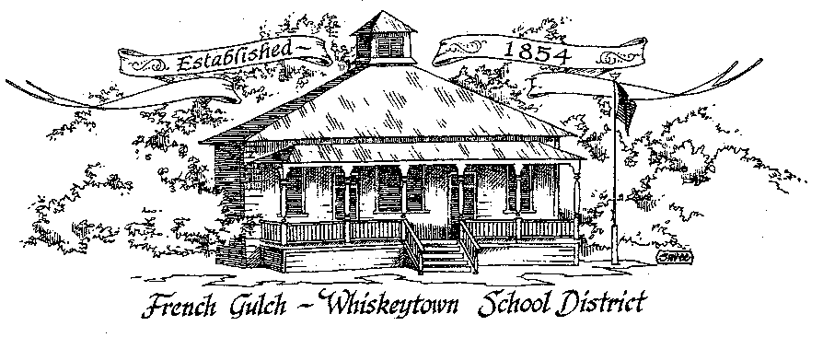

Certificated Position French Gulch-Whiskeytown School Lower Elementary K-3
This position is in a small rural setting. Two aides are assigned to the assignment. Two classrooms are available for instruction adjoined by a center work space. An understanding of Montessori pedagogy is desired but not required. Starting date: August 15, 2022
Contact Information
Name
Address
Phone Number
Email

Educational Background
School College/ University | Dates Attended | Major | Degree Earned/Date

Previous Related Experience
Position Held | Employment Dates | Assigned Duties | Reason for Leaving

References
Name | Relationship | Contact Number

Please submit with a cover letter of intent and a resume to:
mcasey@frenchgulchschool.com
or
Moira Casey POB 368 French Gulch, CA 96033

