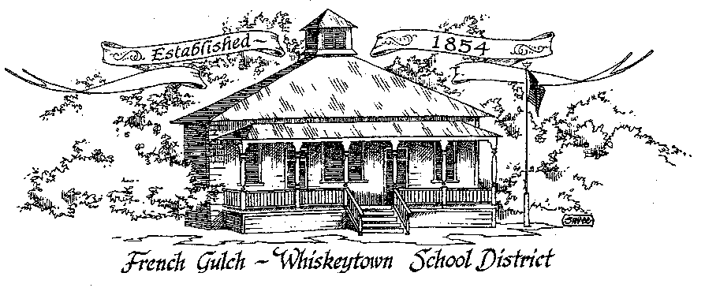

French Gulch-Whiskeytown School District
11442 Cline Gulch Rd., French Gulch, CA 96033
530-359-2151

REGULAR MEETING OF THE GOVERNING BOARD

August 16, 2022
5:00 PM

OUR DISTRICT MISSION
The French Gulch-Whiskeytown School District is dedicated to building resourceful, respectful, academically strong individuals.
CALL TO ORDER & OPEN SESSION
5:00 PM
1. CALL TO ORDER
ROLL CALL
Heather VanHorn, President ☐ Lesley Pearson, Clerk ☐
Keli Laws ☐ Sara Wells ☐ Crystal Andersen ☐

2. OPPORTUNITY FOR PUBLIC COMMENT ON AGENDA ITEMS

Public Comment on any item of interest to the public that is within the Board’s jurisdiction will be heard. The Board may limit comments to no more than 3 minutes pursuant to Board policy. Public comment will also be allowed on each specific agenda.

3. APPROVAL OF AGENDA:

4. CORRESPONDENCE:

5. APPROVAL OF MINUTES:
5.1 APPROVAL OF MINUTES FROM APRIL 19, 2022 REGULAR MEETING
5.2 APPROVAL OF MINUTES FROM MAY 17, 2022 REGULAR MEETING
5.3 APPROVAL OF MINUTES FORM JUNE 17, 2022 MEETING
5.3 APPROVAL OF MINUTES FROM JUNE 20, 2022 SPECIAL MEETING
5.4 APPROVAL OF MINUTES FROM JULY 7, 2022 SPECIAL MEETING

6. REPORTS AND PUBLIC FORUM (if applicable)
6.1 SUPERINTENDENT REPORT:
a. Potential Staffing
b. First Day Parent/Student Breakfast
c. Kitchen Progress
d. Home Schooling/Independent Study Parameters

7. DISCUSSION ITEMS and/or PUBLIC HEARING (if applicable)
7.1 DISPOSAL OF SURPLUS, OBSOLETE OR UNNEEDED BOOKS, EQUIPMENT & SUPPLIES POLICY
7.2 HOME SCHOOL/INDEPENDENT STUDY PACKET/POLICY

8. ACTION ITEMS:
8.1 APPROVAL OF WARRANTS JUNE 21, 2022 – AUGUST 15, 2022
8.2 APPROVAL OF SURPLUS OF SURPLUS, OBSOLETE OR UNNEEDED BOOKS, EQUIPMENT & SUPPLIES POLICY
8.3 APPROVAL TO DISCARD OUTDATED MACBOOK AND REFRIGERTOR
8.4 APPROVAL OF HOMESCHOOL/INDEPENDENT STUDY POLICY

9. PLANNING:

9.1 ITEMS FROM THE FLOOR: Comments, Suggestions for future meetings, etc.
9.2 Next Meeting of the Board: September20, 2022 at 5:00 PM
9.3 OTHER IMPORTANT DATES:
AUGUST 17, 2022- SCHOOL STARTS

10. ADJOURNMENT
10.1 Adjourn Meeting

In compliance with the Americans with Disabilities Act, the French Gulch-Whiskeytown School District will make available to any member of the public who has a disability, appropriate disability-related modifications or accommodations in order for that person to participate in the public meeting. Contact Kristin George in the Office of the Superintendent, French Gulch-Whiskeytown School District Office, 11442 Cline Gulch Rd., French Gulch, California, at (530) 359-2151 at least 48 hours prior to the scheduled meeting. We will make every effort to give primary consideration to expressed preferences, or provide equally effective means of communication to ensure equal access to French Gulch-Whiskeytown School District public meetings.
All documents presented to the members of the Governing Board for consideration at this meeting are included in this agenda packet. Documents unavailable at the time of the printing of this agenda are available for public review in the District Office, 11442 Cline Gulch Rd, during regular business hours. The public is invited and encouraged to attend and participate in Board Meetings. Persons wishing to address the Board may do so during the Opportunity for Public Comment. Speakers are limited to three minutes each. Other opportunities to address the Board include the Public Forum and Items from the Floor. By law, the Board is not allowed to take action on matters that are not on the agenda.

