Weekly Newsletter May 27, 2022
French Gulch-Whiskeytown School
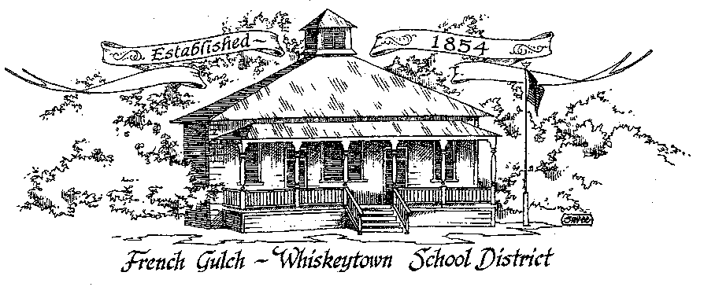
Upcoming Events
May 30
Memorial Day no school

June 7
8th Grade Graduation and Kindergarten Moving Up Ceremony
6:00 pm

June 7
CA Primary Elections

June 8
Last day of School Minimum Day

June 13-July 8
Summer School and SHARE

LUNCH MENU
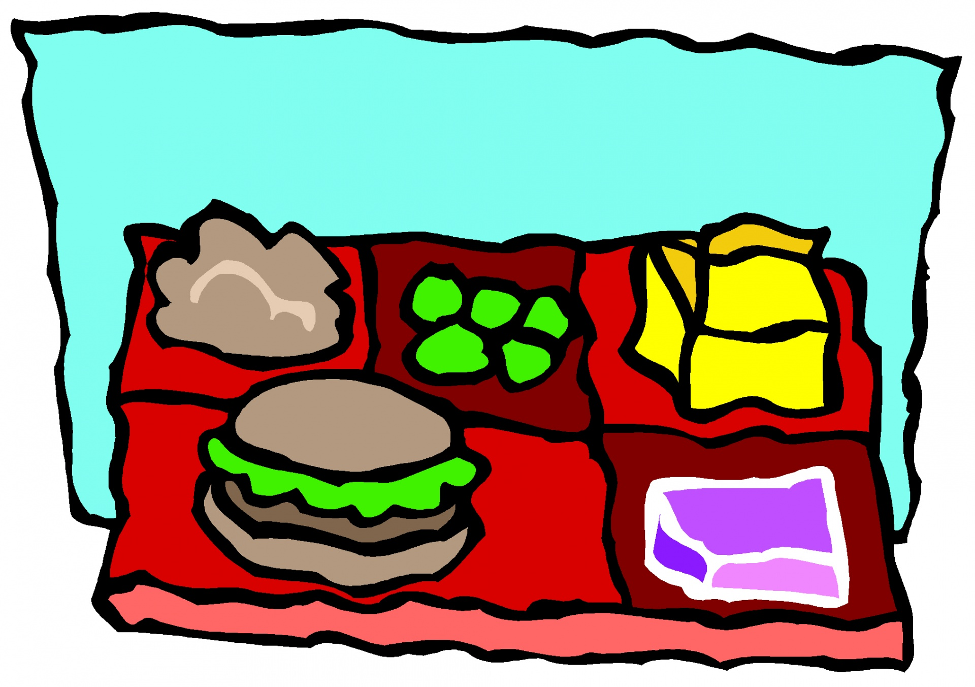
Menu for May 30-June 3
Monday: Memorial Day – no school
Tuesday: Chef Salad w/Chicken, fresh fruit and a biscuit
Wednesday: Beefy Nachos, cherry tomatoes, refried beans and fruit
Thursday: Chicken Nuggets, French fries, cole slaw and fruit
Friday: Pepperoni Pizza, small green salad, baby carrots and fruit
Milk served at every meal

Se

FGWS Parents and Guardians: the FGWS staff mourns with the rest of the nation over the senseless loss of 21 precious lives in Texas this week- 19 children and 2 teachers. Not to be forgotten are the injured children who face a long road to both physical and emotional recovery. The emotional scars of all involved will be carried for a lifetime. We are grateful that since the modernization of FGWS, we at least have visual site of the main entrance to the school. Prior to our offices being moved up front under the eaves, there was one office buried in the middle of the building. It may be too optimistic to think that the unspeakable event at Robb Elementary is the last of its kind but know that we continue to plan for the unthinkable without generating undue anxiety in our students.
SCIENCE IN THE LOWER GRADES
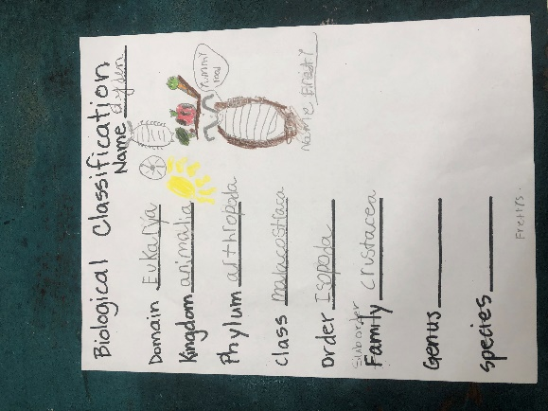
Here is an example of what our lower elementary students are learning to do with Dr. Fernau. This biological classification chart was done by 3rd grader Ayden Chapman. Nice job, Ayden!
MEMORIAL DAY
It is important for our children to understand that Memorial Day is more than a holiday from school. Please take a moment to discuss its significance with your child.
The coming up primary elections are a perfect segue into Memorial Day and the significance of what it took to have free elections. We have a civic obligation to exercise that right. VOTE ON JUNE 7!!

Two board meetings in June! June 17 at 5:00 pm and June 20 at 5:00pm. Agenda topics include the 2022-23 LCAP and Budget.

8th grade graduation and Kindergarten Moving Up ceremony on June 7 at 6:00 pm Last Day of School is June 8. It is a minimum day.

