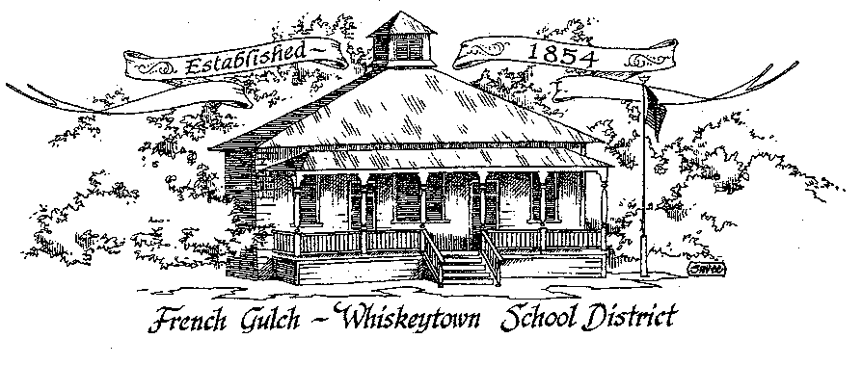

French Gulch-Whiskeytown School District
11442 Cline Gulch Rd., French Gulch, CA 96033
530-359-2151

REGULAR MEETING OF THE GOVERNING BOARD

September 20, 2022 5:00 PM

OUR DISTRICT MISSION
The French Gulch-Whiskeytown School District is dedicated to building resourceful, respectful, academically strong individuals.
CALL TO ORDER & OPEN SESSION
5:00 PM
1. CALL TO ORDER
ROLL CALL
Heather VanHorn, President ☐ Lesley Pearson, Clerk ☐ Keli Laws ☐

Sara Wells ☐ Crystal Andersen ☐
2. OPPORTUNITY FOR PUBLIC COMMENT ON AGENDA ITEMS:

Public Comment on any item of interest to the public that is within the Board’s jurisdiction will be heard. The Board may limit comments to no more than 3 minutes pursuant to Board policy. Public comment will also be allowed on each specific agenda.

3. APPROVAL OF AGENDA:

4. CORRESPONDENCE:
4.1 LETTER FROM MOUNTAIN VALLEY JPA ON THEIR ADOPTED BUDGET
4.2 LETTER FROM JESSICA BIGBY ON LCAP APPROVAL

5. APPROVAL OF MINUTES:
5.1 APPROVAL OF MINUTES FROM APRIL 19, 2022 REGULAR MEETING
5.2 APPROVAL OF MINUTES FROM MAY 17, 2022 REGULAR MEETING
5.3 APPROVAL OF MINUTES FORM JUNE 17, 2022 MEETING
5.3 APPROVAL OF MINUTES FROM JUNE 20, 2022 SPECIAL MEETING
5.4 APPROVAL OF MINUTES FROM JULY 7, 2022 SPECIAL MEETING
5.5 APPROVAL OF MINUTES FROM AUGUST 16, 2022 REGULAR MEETING

6. REPORTS AND PUBLIC FORUM: (if applicable)
6.1 SUPERINTENDENT REPORT
a. Recognition of Linda Swayne and Bob Brass for their years of service to FGWS
b. School opening updates
c. New hires
d. Continues search for lower elementary teacher-progress
e. Moira Casey role after October 1, 2022
f. PULSE PANEL debit cards and appropriate expenditures

g. New ruling on relaxed Covid testing

7. DISCUSSION ITEMS and/or PUBLIC HEARING: (if applicable)
7.1 PUBLIC FORUM HEARING OF PERSONS WISHING TO ADDRESS THE BOARD
Open Public Hearing to receive comments on the Adoption of Resolution 9-22-23, that every pupil has sufficient or insufficient textbooks/instructional materials consistent with the cycles of the curriculum framework adopted by the State Board of Education.

7.2 CONAPP REPORT UPDATE
7.3 PRESENTATION OF BELL SCHEDULE
7.4 PRESENTATION OF THE INDEPENDENT STUDY POLICY
7.5 PRESENTATION OF THE COVID PLAN FOR 2022-23

8. ACTION ITEMS:
8.1 APPROVAL OF THE WARRANTS: 8/16/2022 to 9/19/2022
8.2 APPROVAL OF RESOLUTION 9-22-23 REGARDING THE SUFFICIENCY OF INSTRUCTIONAL MATERIALS
8.3 APPROVAL OF THE 22-23 UNAUDITED ACTUALS
8.4 APPROVAL OF THE RESOLUTION 1-22-23 FOR ADOPTING THE GANN LIMIT
8.5 APPROVAL OF BELL SCHEDULE
8.6 APPROVAL OF INDEPENDENT STUDY POLICY
8.7 APPROVAL OF COVID PLAN FOR 2022-23

9. PLANNING:
9.1 ITEMS FROM THE FLOOR: Comments, Suggestions for future meetings, etc.
9.2 Next Regular Meeting of the Board: OCTOBER 18, 2022 at 5:00 PM
OCTOBER 3- MINIMUM DAY

10. ADJOURNMENT:
10.1 Adjourn Meeting

In compliance with the Americans with Disabilities Act, the French Gulch-Whiskeytown School District will make available to any member of the public who has a disability, appropriate disability-related modifications or accommodations in order for that person to participate in the public meeting. Contact Kristin George in the Office of the Superintendent, French Gulch-Whiskeytown School District Office, 11442 Cline Gulch Rd., French Gulch, California, at (530) 359-2151 at least 48 hours prior to the scheduled meeting. We will make every effort to give primary consideration to expressed preferences, or provide equally effective means of communication to ensure equal access to French Gulch-Whiskeytown School District public meetings.
All documents presented to the members of the Governing Board for consideration at this meeting are included in this agenda packet. Documents unavailable at the time of the printing of this agenda are available for public review in the District Office, 11442 Cline Gulch Rd, during regular business hours. The public is invited and encouraged to attend and participate in Board Meetings. Persons wishing to address the Board may do so during the meeting.

