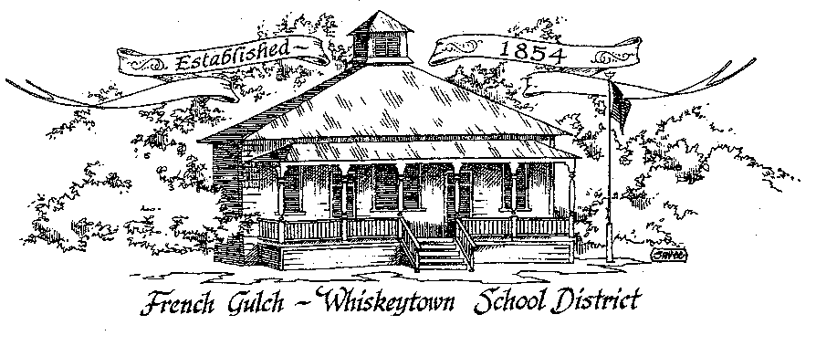

French Gulch-Whiskeytown School District
11442 Cline Gulch Rd., French Gulch, CA 96033
530-359-2151

REGULAR MEETING OF THE GOVERNING BOARD

March 15, 2022 5:00 PM

OUR DISTRICT MISSION
The French Gulch-Whiskeytown School District is dedicated to building resourceful, respectful, academically strong individuals.
CALL TO ORDER & OPEN SESSION
5:00 PM

1. CALL TO ORDER
ROLL CALL
Heather VanHorn, President ☐ Lesley Pearson, Clerk ☐
Crystal Andersen ☐ Sara Wells ☐ Keli Laws €

2. OPPORTUNITY FOR PUBLIC COMMENT ON AGENDA ITEMS

Public Comment on any item of interest to the public that is within the Board’s jurisdiction will be heard. The Board may limit comments to no more than 3 minutes pursuant to Board policy. Public comment will also be allowed on each specific agenda.

3. APPROVAL OF AGENDA:

4. CORRESPONDENCE:
Audit Report

5. APPROVAL OF MINUTES:
5.1 APPROVE MINUTES FROM FEBRUARY 15, 2022 BOARD MEETING

6. REPORTS AND PUBLIC FORUM (if applicable)
6.1 SUPERINTENDENT REPORT:
a. Kitchen grant update
b. Saturday School update
c. ADA/new student
d. Masks/Covid
f. legal notice of board appointment in Record Searchlight

7. DISCUSSION ITEMS and/or PUBLIC HEARING (if applicable)

7.1 PRESENTATION AND DISCUSSION OF THE 2022-2023 SCHOOL CALENDAR
7.2 PRESENTATION AND DISCUSSION OF 2ND INTERIM BUDGET
7.3 DISCUSSION OF LCAP EXPENDITURES FOR 2022-23 AND CHANGES IN EXPENDITURE FOR 2021-20
7.4 ADMINISTRATIVE SERVICES FOR 2022-23

8. ACTION ITEMS:

8.1 APPROVAL OF WARRANTS FEBRUARY 16, 2022 – MARCH 14, 2022
8.2 APPROVAL OF THE 2ND INTERIM BUDGET
8.3 APPROVAL OF THE 22-23 STUDENT CALENDAR
8.4 APPROVAL OF DISCARD OF OLD KITCHEN APPLIANCES
8.5 APPROVAL OF 2020-21 AUDIT REPORT
8.6 APPROVAL OF THIRD QUARTERLY REPORT ON “WILLIAMS UNIFORM COMPLAINTS”

9. PLANNING:

9.1 ITEMS FROM THE FLOOR: Comments, Suggestions for future meetings, etc.
9.2 Next Meeting of the Board: APRIL 19, 2022, 5:00 PM
9.3 OTHER IMPORTANT DATES:
March 12 & 19, 2022: Saturday School
April 11-15, 2022: Spring Break

10. ADJOURNMENT
10.1 Adjourn Meeting

In compliance with the Americans with Disabilities Act, the French Gulch-Whiskeytown School District will make available to any member of the public who has a disability, appropriate disability-related modifications or accommodations in order for that person to participate in the public meeting. Contact Kristin George in the Office of the Superintendent, French Gulch-Whiskeytown School District Office, 11442 Cline Gulch Rd., French Gulch, California, at (530) 359-2151 at least 48 hours prior to the scheduled meeting. We will make every effort to give primary consideration to expressed preferences, or provide equally effective means of communication to ensure equal access to French Gulch-Whiskeytown School District public meetings.
All documents presented to the members of the Governing Board for consideration at this meeting are included in this agenda packet. Documents unavailable at the time of the printing of this agenda are available for public review in the District Office, 11442 Cline Gulch Rd, during regular business hours. The public is invited and encouraged to attend and participate in Board Meetings. Persons wishing to address the Board may do so during the Opportunity for Public Comment. Speakers are limited to three minutes each. Other opportunities to address the Board include the Public Forum and Items from the Floor. By law, the Board is not allowed to take action on matters that are not on the agend

