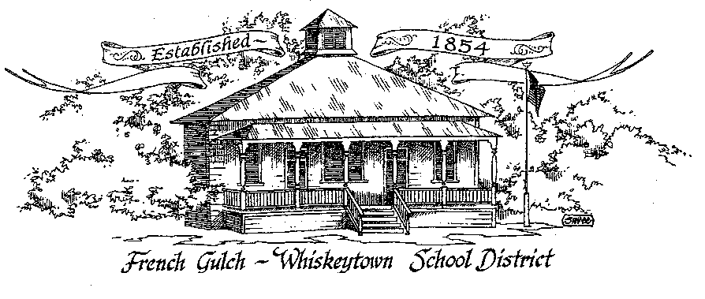

Successful students today – Successful citizen’s tomorrow

French Gulch-Whiskeytown School District
11442 Cline Gulch Rd., French Gulch, CA 96033
530-359-2151

SPECIAL MEETING OF THE GOVERNING BOARD

July 7, 2022 10:30 AM
Minutes

OUR DISTRICT MISSION
The French Gulch-Whiskeytown School District is dedicated to building resourceful, respectful, academically strong individuals.
CALL TO ORDER & OPEN SESSION
10:30 am
1. CALL TO ORDER 10:32
ROLL CALL
Heather VanHorn, President x☐ Lesley Pearson, Clerk x☐
Keli Laws x☐ ☐ Sara Wells ☐ Crystal Andersen €
2. OPPORTUNITY FOR PUBLIC COMMENT ON AGENDA ITEMS

Public Comment on any item of interest to the public that is within the Board’s jurisdiction will be heard. The Board may limit comments to no more than 3 minutes pursuant to Board policy. Public comment will also be allowed on each specific agenda.
None

3. APPROVAL OF AGENDA - Move to approve by Lesley Pearson Second by Keli Laws
Ayes: 3 Nays: 0

4. CORRESPONDENCE –
None
5. APPROVAL OF MINUTES-
Deferred to regular meeting August 16, 2022

6. REPORTS AND PUBLIC FORUM (if applicable)
6.1 SUPERINTENDENT REPORT-
a. Summer School
Last day is tomorrow. Regular group of 6 students but as many as 11. Several older students have dropped by and received coding lessons with Bob who had attended a 3 day training last month
b. November Elections
Reminder: Heather, Lesley and Keli need to register at the County Clerk's office between July 18 and August 12 if intending on staying on the board

DISCUSSION ITEMS and/or PUBLIC HEARING (if applicable)
PUBLIC FORUM HEARING OF PERSONS WISHING TO ADDRESS THE BOARD
None

7.1 Resolutions regarding the November Elections
The 3 board resolutions regarding the upcoming general election were reviewed

ACTION ITEMS –

8.1 APPROVAL OF RESOLUTION 26-22-23 ORDERING GOVERNING BOARD MEMBER
ELECTION
8.2 APPROVAL OF RESOLUTION 27-22-23 COST OF CANDIDATE STATEMENTS
8.4 APPROVAL OF RESOLUTION #28-22-233 PROCEDURE IN CASE OF TIE VOTE AT
GOVERNING BOARD ELECTION

Lesely moved to approve all three resolutions. Keli seconded the motion.

AYES: 3 Nays: 0

PLANNING-
9.1 ITEMS FROM THE FLOOR: Comments, Suggestions for future meetings, etc.
None
9.2 Next Meeting of the Board: August 16, 2022
10. ADJOURNMENT-
10.1 Adjourn Meeting 10:40 am

In compliance with the Americans with Disabilities Act, the French Gulch-Whiskeytown School District will make available to any member of the public who has a disability, appropriate disability-related modifications or accommodations in order for that person to participate in the public meeting. Contact Kristin George in the Office of the Superintendent, French Gulch-Whiskeytown School District Office, 11442 Cline Gulch Rd., French Gulch, California, at (530) 359-2151 at least 48 hours prior to the scheduled meeting. We will make every effort to give primary consideration to expressed preferences, or provide equally effective means of communication to ensure equal access to French Gulch-Whiskeytown School District public meetings.
All documents presented to the members of the Governing Board for consideration at this meeting are included in this agenda packet. Documents unavailable at the time of the printing of this agenda are available for public review in the District Office, 11442 Cline Gulch Rd, during regular business hours. The public is invited and encouraged to attend and participate in Board Meetings. Persons wishing to address the Board may do so during the Opportunity for Public Comment. Speakers are limited to three minutes each. Other opportunities to address the Board include the Public Forum and Items from the Floor. By law, the Board is not allowed to take action on matters that are not on the agenda.

