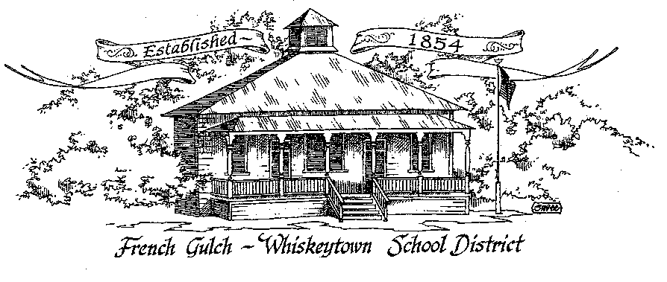

French Gulch-Whiskeytown School District

11442 Cline Gulch Rd., French Gulch, CA 96033

530-359-2151

SPECIAL MEETING OF THE GOVERNING BOARD

February 28, 2023 5:00 PM

OUR DISTRICT MISSION

The French Gulch-Whiskeytown School District is dedicated to building resourceful, respectful, academically strong individuals.

**CALL TO ORDER & OPEN SESSION**

5:00 PM

**1. CALL TO ORDER**



ROLL CALL

Heather VanHorn, President ☐ Lesley Pearson, Clerk ☐

Crystal Andersen ☐ Sara Wells ☐ Keli Laws ☐

**2. OPPORTUNITY FOR PUBLIC COMMENT ON AGENDA ITEMS**

Public Comment on any item of interest to the public that is within the Board’s jurisdiction will be heard. The Board may limit comments to no more than 3 minutes pursuant to Board policy. Public comment will also be allowed on each specific agenda.

**3. APPROVAL OF AGENDA:**

**4. CORRESPONDENCE:**

4.1 LETTER FROM SCOE REGARDING FIRST INTERIM BUDGET

4.2 LETTER FROM SCOE REGARDING MOUNTAIN VALLEY JPA BUDGET

4.3 LETTER FROM HORTON MCNULTY & SAETURN REGARDING AUDIT FINDINGS

4.4 LETTER FROM CA SCHOOL BOARDS ASSOCIATION REGARDING BALLOT SIGNING

4.5 FAR NORTHERN REGIONAL CENTER EARLY START SERVICES

**5. APPROVAL OF MINUTES:**

5.1 APPROVE MINUTES OF THE JANUARY 17,, 2023 BOARD MEETING

5.2 APPROVE MINUTES OF NOVEMBER 15 , 2022 BOARD MEETING

**6. REPORTS AND PUBLIC FORUM: (if applicable)**

6.1 SUPERINTENDENT REPORT:

a.  UPDATE ON OPEN POSITIONS

b.  PULSE PANEL CARDS

c.  SATURDAY SCHOOL

d.  4-6th GRADE GIRLS STEM SEMINAR AT SHASTA COLLEGE

e.  JUMP ROPE FOR HEART UPDATE

f. CUSTODIAL MENTOR FOR JOEY VANHORN

g. UPDATE ON GRANTS

**7. DISCUSSION ITEMS and/or PUBLIC HEARING (if applicable)**

7.1STUDENT/PARENT SURVEY RESULTS

7.2 REVIEW OF EOP PLAN

**8. ACTION ITEMS**:

8.1 APPROVAL OF WARRANTS 1/20/2023 THROUGH  2/15/2023

               8.2 APPROVAL OF THE FGWS EMERGENCY OPERATIONS PROCEDURE HANDBOOK

8.3 **APPROVAL OF HIRING RENEE RALEY TO REPLACE KRISTIN GEORGE’S OFFICE**

**9. PLANNING:**

9.1 ITEMS FROM THE FLOOR: Comments, Suggestions for future meetings, etc.

9.2 Next Meeting of the Board: MARCH 21,2023 at 5:00 pm

9.3 OTHER IMPORTANT DATES:

* FEBRUARY 20 TO 24: PRESIDENTS WEEK
* FEBRUARY 28: 2ND TRI MESTER ENDS

**10. ADJOURNMENT:**

10.1 Adjourn Meeting



In compliance with the Americans with Disabilities Act, the French Gulch-Whiskeytown School District will make available to any member of the public who has a disability, appropriate disability-related modifications or accommodations in order for that person to participate in the public meeting. Contact Kristin George in the Office of the Superintendent, French Gulch-Whiskeytown School District Office, 11442 Cline Gulch Rd., French Gulch, California, at (530) 359-2151 at least 48 hours prior to the scheduled meeting. We will make every effort to give primary consideration to expressed preferences, or provide equally effective means of communication to ensure equal access to French Gulch-Whiskeytown School District public meetings.

All documents presented to the members of the Governing Board for consideration at this meeting are included in this agenda packet. Documents unavailable at the time of the printing of this agenda are available for public review in the District Office, 11442 Cline Gulch Rd, during regular business hours. The public is invited and encouraged to attend and participate in Board Meetings. Persons wishing to address the Board may do so during the Opportunity for Public Comment. Speakers are limited to three minutes each. Other opportunities to address the Board include the Public Forum and Items from the Floor. By law, the Board is not allowed to take action on matters that are not on the agenda.