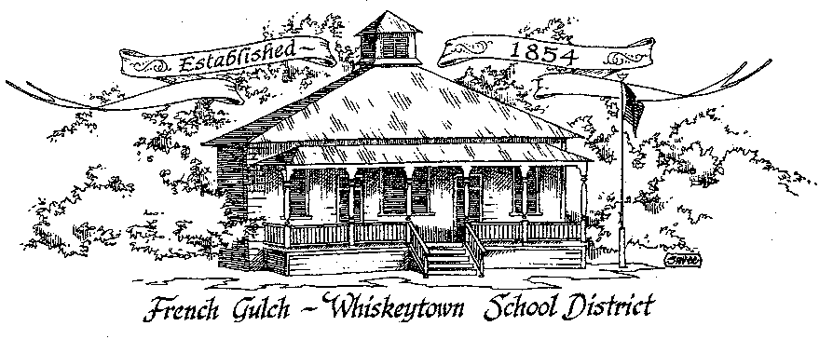

French Gulch-Whiskeytown School District
11442 Cline Gulch Rd., French Gulch, CA 96033
530-359-2151

ANNUAL ORGANIZATIONAL MEETING OF THE GOVERNING BOARD

December 20, 2022 5:00 PM
MINUTES

OUR DISTRICT MISSION
The French Gulch-Whiskeytown School District is dedicated to building resourceful, respectful, academically strong individuals.
CALL TO ORDER & OPEN SESSION
5:00 PM

1. CALL TO ORDER
ROLL CALL
Heather VanHorn, President ☒ Lesley Pearson, Clerk ☒
Keli Laws ☐ Sara Wells ☒ Crystal Andersen €

2. OPPORTUNITY FOR PUBLIC COMMENT ON AGENDA ITEMS

Public Comment on any item of interest to the public that is within the Board’s jurisdiction will be heard. The Board may limit comments to no more than 3 minutes pursuant to Board policy. Public comment will also be allowed on each specific agenda.
Donna Brashears addressed the board regarding her position as the “clay instructor.” She currently is paid on the classified instructional aide scale. Although not “credentialed” as an art instructor, she believes her expertise deserves another consideration as a specialist separate from an instructional aide for the planning, instruction, acquisition of materials and execution of the clay program as a whole.
3. APPROVAL OF AGENDA:
Dr. Casey requested an addendum to the agenda to include board approval to discard a refrigerator replaced in the kitchen remodel.
Lesley Pearson moved to approve the agenda as amended, 2nd by Sara Wells motion passed ayes 3 nays 2
4. CORRESPONDENCE:
4.1 MEMORANDUM FROM STSIG ON CERTIFICATE OF WORKERS COMPENSATION
4.2 CALIFORNIA STATE CONTROLLER OFFICE INITIALTING A NEW DATA PORTAL FOR GOVERNMENTS COMPENSATION IN CALIFORNIA REPORT SUBMITIONS

5. APPROVAL OF MINUTES:
5.1 APPROVE MINUTES OF THE NOVEMBER 15, 2022 BOARD MEETING
December absence of November attendees needed to approve. Deferred to January meeting,
6. REPORTS AND PUBLIC FORUM (if applicable)
6.1 SUPERINTENDENT REPORT:
a. December attendance/enrollment
1 new student enrolled: total enrollment: 20 numerous absences this month due to long lasting viral infections. We have been attempting IS as much as possible to both make up overall attendance and to provide students with ongoing work
b. School/Holiday Evening
We canceled this event in an abundance of caution to prevent further spread of the various viral infections both staff and students have been catching- community event might increase the viral load.
c. Ongoing Search for certificated instructor update
Still searching… one potential candidate has to have a foreign BA independently evaluated to see if it is equivalent to a US university degree. If it is we could possibly move forward with a temporary permit. The candidate does have school experience as an instructional aide.
d. Music teacher update
Karen Hafenstein had to have foot surgery. She will be unable to bear weight on it until April. Penny Bergstrom, a former music teacher here will be asked if she’s interested in returning on a temporary basis to provide instrumental and vocal music.
e. clarification of one time only July coverage of insurance for Linda Swayne
In order for Linda to complete a full summer school teaching assignment, she delayed her retirement one month. This saved the district from finding a teacher replacement for the summer school which extended into July. STRS retirees are not allowed to be employed in a school for180 days past their retirement date. Her original retirement date of June 30, 2022 would not have allowed her pay for services rendered in July.
f. Staff workshop on Restorative Justice on January 9, 2023
SCOE is offering a workshop on Restorative Justice at the PDC the day before students return from Winter Break
g. Addendum add on: SHARE refrigerator
With the addition of new appliances in the kitchen discarded but functional ones were stored in the bus barn. Initially Project SHARE determined that one refrigerator was theirs and they wanted it for the program at Shasta High. They have since abandoned the need for it and told FGWS to give it away. Board approval to declare it surplus property is needed to give it a home other than the valuable real estate it is taking up in the bus barn.

6.2 PRESENTATION OF THE 21-22 ANNUAL DEVELOPMENT FEE REPORT & CAPITAL FACILITY FUND REPORT TO BE APPROVED AT THE REGULAR JANUARY 2023 BOARD MEETING
The Board noted the new square foot rate in the Developers Fee report. We will decide what to spend current accrued balance on at a later date.
6.3 PRESENTATION OF THE 1ST INTERIM BUDGET
The district is able to meet its financial obligations 3 years out but with the uncertainty of meeting funding Band 2 year to year, conservative spending is necessary.

7. DISCUSSION ITEMS and/or PUBLIC HEARING (if applicable)
7.1 DISCUSSION OF THE BOARD SCHEDULE TO BE APPROVED OF UNDER RESOLUTION #13-22-23 FIXING DATE, TIME, AND LOCATION OF REGULAR MEETINGS
With most members having children in various extracurricular activities, it’s hard to set to a fixed day that will meet everyone’s family obligations. Those present agreed that we would stick with the 3rd Tuesday of the month at 5:00 pm at FGWS. Phone calls and zoom outreaches will be used if necessary to meet a quorum.
7.2 DISCUSSION OF OFFICES OF THE BOARD BEING REASSIGNED
Present members decided to keep current officers and member roles: Heather VanHorn: president, Lesley Pearson: clerk, Sara Wells, Crystal Andersen and Keli Laws:members.
7.3 MINIMUM WAGE INCREASE JANUARY 1, 2023
Classified salary schedules will reflect the $15.50 minimum wage increase. The rest of the salary scale with be adjusted through negotiations.
7.4 GENERAL NEGOTIATIONS TIMELINE
In the past negotiations typically were conducted at the end of the year. It is suggested that that process be moved up in light of the $1.50/hr minimum wage increase for beginning salaries to achieve equity in the 2022-23 year.
7.5 MILEAGE REIMBURSEMENT FOR PRESCHOOL STUDENT RECEIVING SPEECH/LANGUAGE SERVICES IN TOWN
Board was informed that the district is responsible for paying mileage to the parents of a preschool child receiving speech and language services in town.
8. ACTION ITEMS:
8.1 APPROVAL OF WARRANTS NOVEMBER 16, 2022 – DECEMBER 20, 2022
8.2 APPROVAL OF THE 1st INTERIM BUDGET
8.3 APPROVAL OF RESOLUTION #13-22-23 REGARDING FIXING DATE, TIME, AND LOCATION OF REGULAR MEETINGS
8.4 APPROVAL OF RAISING THE MINIMUM WAGE ON CLASSIFIED SALARY SCHEDULE TO $15.50/HR
8.5 APPROVAL OF INSURANCE CAP FROM $10,000 TO $11,000
8.6 APPROVAL OF ONE TIME ONLY JULY 2022 INSURANCE COVERAGE FOR LINDA SWAYNE
8.7 ADDENDUM ITEM: DECLARE SHARE REFRIGERATOR SUPLUS EQUIPMENT AVAILABLE FOR DISCARD AND SALE FOR $1.00 TO INDIVIDUAL WILLING TO REMOVE IT FROM SCHOOL PROPRETY. FGWS NOT RESPONSIBLE FOR GUARANTEEING WORKING ORDER.
Each action item briefly discussed. Lesely Pearson moved to vote on the items as a slate. Second by Sara Wells ayes 3 nays 0
9. PLANNING:

9.1 ITEMS FROM THE FLOOR: Comments, Suggestions for future meetings, etc.
None
9.2 Next Meeting of the Board: January 17, 2023
9.3 OTHER IMPORTANT DATES:
DECEMBER 22, 2022- LAST DAY OF SCHOOL, MINIMUM DAY
JANUARY 10, 2023- RETURN TO SCHOOL
JANUARY 16, 2023- NO SCHOOL

10. ADJOURNMENT
10.1 Adjourn Meeting

In compliance with the Americans with Disabilities Act, the French Gulch-Whiskeytown School District will make available to any member of the public who has a disability, appropriate disability-related modifications or accommodations in order for that person to participate in the public meeting. Contact Kristin George in the Office of the Superintendent, French Gulch-Whiskeytown School District Office, 11442 Cline Gulch Rd., French Gulch, California, at (530) 359-2151 at least 48 hours prior to the scheduled meeting. We will make every effort to give primary consideration to expressed preferences, or provide equally effective means of communication to ensure equal access to French Gulch-Whiskeytown School District public meetings.
All documents presented to the members of the Governing Board for consideration at this meeting are included in this agenda packet. Documents unavailable at the time of the printing of this agenda are available for public review in the District Office, 11442 Cline Gulch Rd, during regular business hours. The public is invited and encouraged to attend and participate in Board Meetings. Persons wishing to address the Board may do so during the Opportunity for Public Comment. Speakers are limited to three minutes each. Other opportunities to address the Board include the Public Forum and Items from the Floor. By law, the Board is not allowed to take action on matters that are not on the agenda.

