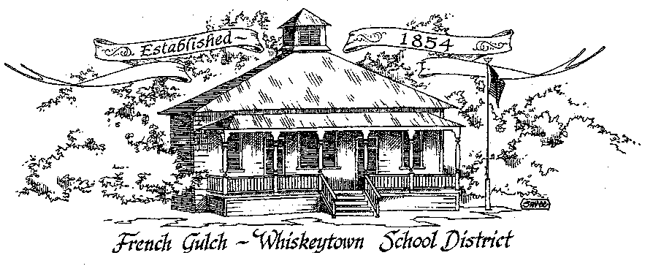

French Gulch-Whiskeytown School District
11442 Cline Gulch Rd., French Gulch, CA 96033
530-359-2151

ANNUAL ORGANIZATIONAL MEETING OF THE GOVERNING BOARD

December 14, 2021 5:00 PM

MINUTES

OUR DISTRICT MISSION
The French Gulch-Whiskeytown School District is dedicated to building resourceful, respectful, academically strong individuals.
CALL TO ORDER & OPEN SESSION
5:00 PM

1. CALL TO ORDER
ROLL CALL
Heather VanHorn, President ☒ Lesley Pearson, Clerk ☒
Sara Wells ☒ Crystal Andersen €

2. OPPORTUNITY FOR PUBLIC COMMENT ON AGENDA ITEMS

Public Comment on any item of interest to the public that is within the Board’s jurisdiction will be heard. The Board may limit comments to no more than 3 minutes pursuant to Board policy. Public comment will also be allowed on each specific agenda.

3. APPROVAL OF AGENDA:
1st: Sara Wells 2nd: Lesley Pearson Ayes: All Opposed: None

4. CORRESPONDENCE:
4.1 MEMORANDUM FROM STSIG ON CERTIFICATE OF WORKERS COMPENSATION

5. APPROVAL OF MINUTES:
5.1 APPROVE MINUTES OF THE NOVEMBER 2, 2021 BOARD MEETING
1st: Sara Wells 2nd: Lesley Pearson Ayes: All Opposed: None

6. REPORTS AND PUBLIC FORUM (if applicable)
6.1 SUPERINTENDENT REPORT:
A. new instructional aide in upper elementary class
Vanessa Knight is working in Renay Hills Classroom
B. resignation of instructional aid in lower elementary class
Michela Rodriguez resigned from Linda’s classroom
C. changes to Effective Educator Grant
D. status/progress on kitchen appliance grant
It’s a literal circus, now involving the state architect and the building department, An extension was granted from the CDE until March
E. review of Monday, November 29th meeting at SCOE with superintendents and board members

6.2 PRESENTATION OF THE 20-21 ANNUAL DEVELOPMENT FEE REPORT & CAPITAL FACILITY FUND REPORT TO BE APPROVED AT THE REGULAR JANUARY 2022 BOARD MEETING
6.3 PRESENTATION OF THE 1ST INTERIM BUDGET

7. DISCUSSION ITEMS and/or PUBLIC HEARING (if applicable)
7.1 DISCUSSION OF THE BOARD SCHEDULE TO BE APPROVED OF UNDER RESOLUTION #13-21-22 FIXING DATE, TIME, AND LOCATION OF REGULAR MEETINGS
Moved to the third Tuesday of each month
7.2 DISCUSSION OF OFFICES OF THE BOARD BEING REASSIGNED
7.3 REVIEW AND DISCUSS CHANGES TO EFFECTIVE EDUCATORS GRANT

8. ACTION ITEMS:
8.1 APPROVAL OF WARRANTS NOVEMBER 3, 2021 – DECEMBER 13, 2021
1st: Lesley Pearson 2nd: Sara Wells Ayes: All Nays: None
8.2 APPROVAL OF THE 1st INTERIM BUDGET
1st: Lesley Pearson 2nd: Sara Wells Ayes: All Nays: None
8.3 APPROVAL OF RESOLUTION #13-21-22 REGARDING FIXING DATE, TIME, AND LOCATION OF REGULAR MEETINGS
1st: Lesley Pearson 2nd: Sara Wells Ayes: All Nays: None
8.4 APPROVE EFFECTIVE EDUCATORS GRANT PLAN
1st: Lesley Pearson 2nd: Sara Wells Ayes: All Nays: None
8.5 APPROVE DICARD OF THE OLD OFFICE COMPUTER
1st: Lesley Pearson 2nd: Sara Wells Ayes: All Nays: None

9. PLANNING:

9.1 ITEMS FROM THE FLOOR: Comments, Suggestions for future meetings, etc.
9.2 Next Meeting of the Board: January 18, 2021
9.3 OTHER IMPORTANT DATES:
DECEMBER 16 2021: PICTURE DAY
DECEMBER 22, 2021: WINTER BREAK BEGINS, LAST DAY OF SCHOOL, MINIMUM DAY
JANUARY 11, 2022: RETURN TO SCHOOL

10. ADJOURNMENT
10.1 Adjourn Meeting

In compliance with the Americans with Disabilities Act, the French Gulch-Whiskeytown School District will make available to any member of the public who has a disability, appropriate disability-related modifications or accommodations in order for that person to participate in the public meeting. Contact Kristin George in the Office of the Superintendent, French Gulch-Whiskeytown School District Office, 11442 Cline Gulch Rd., French Gulch, California, at (530) 359-2151 at least 48 hours prior to the scheduled meeting. We will make every effort to give primary consideration to expressed preferences, or provide equally effective means of communication to ensure equal access to French Gulch-Whiskeytown School District public meetings.
All documents presented to the members of the Governing Board for consideration at this meeting are included in this agenda packet. Documents unavailable at the time of the printing of this agenda are available for public review in the District Office, 11442 Cline Gulch Rd, during regular business hours. The public is invited and encouraged to attend and participate in Board Meetings. Persons wishing to address the Board may do so during the Opportunity for Public Comment. Speakers are limited to three minutes each. Other opportunities to address the Board include the Public Forum and Items from the Floor. By law, the Board is not allowed to take action on matters that are not on the agenda.

