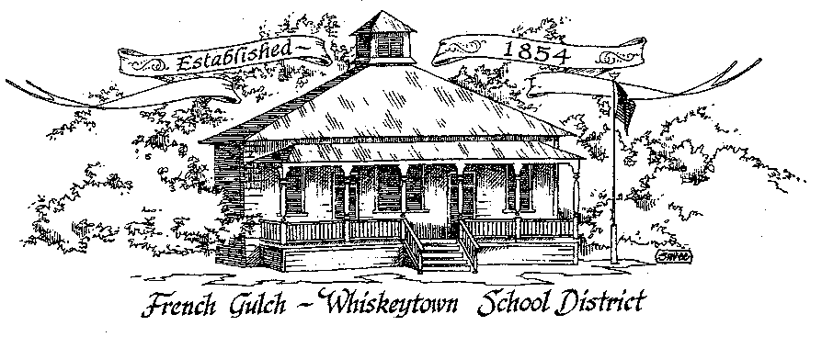

French Gulch-Whiskeytown School District

11442 Cline Gulch Rd., French Gulch, CA 96033
530-359-2151

REGULAR MEETING OF THE GOVERNING BOARD

April 19, 2022 5:00 pm

OUR DISTRICT MISSION
The French Gulch-Whiskeytown School District is dedicated to building resourceful, respectful, academically strong individuals.

CALL TO ORDER & OPEN SESSION
5:00 PM

1. CALL TO ORDER
ROLL CALL
Heather VanHorn, President ☐ Lesley Pearson, Clerk ☐
Keli Laws ☐ Sara Wells ☐ Crystal Andersen ☐

2. OPPORTUNITY FOR PUBLIC COMMENT ON AGENDA ITEMS

Public Comment on any item of interest to the public that is within the Board’s jurisdiction will be heard. The Board may limit comments to no more than 3 minutes pursuant to Board policy. Public comment will also be allowed on each specific agenda.

3. APPROVAL OF AGENDA -

4. CORRESPONDENCE -
4.1 PROPOSAL FOR SERVICES FROM OUR AUDITOR, HORTON MCNULTY & SAETEURN
4.2 LETTER FROM THE STATE WATER RESOURCES CONTROL BOARD

5. APPROVAL OF MINUTES-
5.1 APPROVE MINUTES OF MARCH 15, 2022 REGULAR BOARD MEETING
5.2 APPROVE MINUTES OF FEBRUARY 15,2022 REGULAR BOARD MEETING

6. REPORTS AND PUBLIC FORUM (if applicable) -
6.1 SUPERINTENDENT REPORT:
a. ADA/Saturday School
b. April 23 Job Fair through MVJPA
c. Summer School/Extended Day through Project SHARE
d. Family Engagement Events
e. Kitchen Update

7. DISCUSSION ITEMS and/or PUBLIC HEARING (if applicable)-

7.1 JUNE BOARD MEETINGS, TWO DATES
7.2 SUPERINTENDENT/PRINICIPAL ROLE 41 DAY/YEAR CONTRACT RECONSIDERATION
7.3 STAFFING CONSIDERATIONS FOR NEXT YEAR
7.4 BOARD CONFIGURATION/REGISTRATION AT COUNTY CLERK’S OFFICE
7.5 DEVELOPER FEE DISUSSION
7.6 LCAP AND EXPANDED LEARNING OPPORTUNITY

8. ACTION ITEMS -
8.1 APPROVAL OF WARRANTS: MARCH 16, 2022 – APRIL 18, 2022
8.2 APPROVAL OF HORTON MCNULTY & SAETEURN AS AUDITOR FOR NEXT 3 YEARS
8.3 ACCEPTANCE OF CATHY VEVODA RESIGNATION

9. PLANNING –

9.1 ITEMS FROM THE FLOOR: Comments, Suggestions for future meetings, etc.
9.2 Next Regular Meeting of the Board: MAY 17, 2022 at 5:00 PM
9.3 OTHER IMPORTANT DATES:
May 30: Memorial Day, No School

10. ADJOURNMENT-
10.1 Adjourn Meeting

I

n compliance with the Americans with Disabilities Act, the French Gulch-Whiskeytown School District will make available to any member of the public who has a disability, appropriate disability-related modifications or accommodations in order for that person to participate in the public meeting. Contact Kristin George in the Office of the Superintendent, French Gulch-Whiskeytown School District Office, 11442 Cline Gulch Rd., French Gulch, California, at (530) 359-2151 at least 48 hours prior to the scheduled meeting. We will make every effort to give primary consideration to expressed preferences, or provide equally effective means of communication to ensure equal access to French Gulch-Whiskeytown School District public meetings.
All documents presented to the members of the Governing Board for consideration at this meeting are included in this agenda packet. Documents unavailable at the time of the printing of this agenda are available for public review in the District Office, 11442 Cline Gulch Rd, during regular business hours. The public is invited and encouraged to attend and participate in Board Meetings. Persons wishing to address the Board may do so during the Opportunity for Public Comment. Speakers are limited to three minutes each. Other opportunities to address the Board include the Public Forum and Items from the Floor. By law, the Board is not allowed to take action on matters that are not on the agenda.

