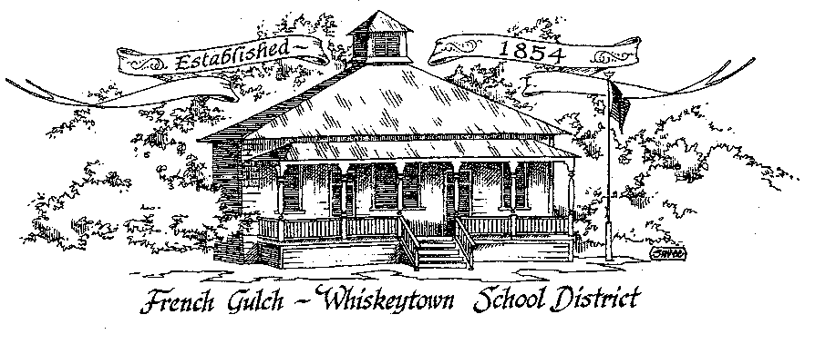

French Gulch-Whiskeytown School District

11442 Cline Gulch Rd., French Gulch, CA 96033
530-359-2151

REGULAR MEETING OF THE GOVERNING BOARD

April 12, 2021 5:00 pm
MINUTES

OUR DISTRICT MISSION
The French Gulch-Whiskeytown School District is dedicated to building resourceful, respectful, academically strong individuals.

CALL TO ORDER & OPEN SESSION
5:00 PM

1. CALL TO ORDER
ROLL CALL
Heather VanHorn, President ☒ Lesley Pearson, Clerk ☒
Matthew Balch ☒ Sara Wells ☐ Crystal Andersen ☒

2. OPPORTUNITY FOR PUBLIC COMMENT ON AGENDA ITEMS

Public Comment on any item of interest to the public that is within the Board’s jurisdiction will be heard. The Board may limit comments to no more than 3 minutes pursuant to Board policy. Public comment will also be allowed on each specific agenda.
There were no public comments.
3. APPROVAL OF AGENDA -
Lesley Pearson moved to accept the agenda second by Crystal Andersen Motion passed: ayes 4 nays 0
4. CORRESPONDENCE -
4.1 LETTER FROM OUR AUDITOR, HORTON MCNULTY & SAETEURN
Letter presented explaining the auditing process by the firm servicing the district- safeguards and assurances regarding the procedures they follow.
4.2 LETTER FROM THE STATE WATER RESOURCES CONTROL BOARD
The State Water Resources Control Board advised the district that California is facing another drought year. Drought impact restricts are likely to be issued in the near future,

5. APPROVAL OF MINUTES-
5.1 APPROVE MINUTES OF MARCH 8, 2021 REGULAR BOARD MEETING
Matthew Balch moved to accept the March 8, 2021 minutes as written motion second by Lesley Pearson. Motion passed 4 ayes 0 nays

6. REPORTS AND PUBLIC FORUM (if applicable) -
6.1 SUPERINTENDENT REPORT:
a. Enrollment
Enrollment is holding at 29- child who was scheduled to reenroll has not done so yet
b. Protest March Follow Up
Former student who had organized a protest march on April 5, 2021 did in fact walk down from Main St to the school on that day. He was protesting based on his assertion that the school failed to separate its interests with the French Gulch Community Church in some of its policies and actions thus violating the principle of separation of church and state. Claims are based on incidents he perceived to illustrate this point two or more years ago when he was a student at FGWS. There has been Email contact with the student discussing his opinions vs the facts. While both the school and the community church strive to be supportive neighbors and have a commitment to stewardship to the people and environment of French Gulch, they never collaborated on issues of doctrine or religious belief. This individual was given some guidelines on how to give his voice in civic matters more credibility by following protocols such as the Universal Complaint Procedure. The school was on its first day of Spring Break on March 5, so the protester was not met by any school officials.
c. Testing
The district will participate in state testing this year but as per a waiver from the federal government not be held for accountability on score and/or participation rate. The test will be half the length it normally is. Mathematics and ELA will be the areas tested. Students in grades 3-8 will participate.

7. DISCUSSION ITEMS and/or PUBLIC HEARING (if applicable)-
7.1 TRACK & FIELD IMPROVEMENTS
Heather VanHorn expressed the need for the track to be re-loamed and reseeded. The track itself needs to be releveled. Given the potential water rationing that is anticipated, perhaps sections of the track area can be designated for this first with a plan to eventually redo the entire area. Heather and Matthew will look into some grants to assist in the costs of the project.
7.2 ELO PLAN: EXTENDED LEARNING OPPORTUNITY
FGWS summer school was discussed (June 7-July2) as well as Project SHARE’s summer program the month of July both to help mitigate learning loss over the course of the pandemic and to prevent summer learning loss.
7.3 PARENT & STUDENT SURVEYS
Both parent and student surveys were presented with disaggregated data. The parent surveys represented about 25% of the student population. Student surveys included students in grades 4-8. Both surveys were generally positive. Results will be posted on the website under the LCAP header.
7.4 COMPENSATION FOR EMPLOYEES
The district has not compensated employees for the past two years, other than the mandated minimum wage increase on the classified salary schedule. Patty Blythe is looking into the matter and will get back to the superintendent in this regard. At issue currently is the district’s drop in revenue funding from Band 2 to 1 for the current year and potential maintenance at that lesser funding level for 2021-22 and adding ongoing expenses. A lump sum off of the salary schedule was discussed as one possible avenue to explore.
7.5 POSSIBLE STAFFING FOR 2021-2022
Donna Brashears has announced her decision to retire in June. She would like to continue her clay program on Fridays with a PSA. Renay Hill is exploring the possibility of a 3/5 assignment in a job sharing situation. Linda Swayne is exploring employment options as well. Lesley Pearson brought up the idea of using student teachers from Simpson or Chico as a possible way to assist in our multigraded classrooms. Finally, Moira Casey announced that while she would consider sharing the Supt/Principal position in a transition year, she does not want to continue in the same capacity she is in now.
7.6 JUNE BOARD MEETINGS, TWO DATES
The board decided on the two June Board Meeting dates: June 14, our regularly scheduled meeting date, and June 16. Both are scheduled for 5 pm.

8. ACTION ITEMS -
8.1 APPROVAL OF WARRANTS: MARCH 8, 2021 – APRIL 9, 2021
Lesley Pearson moved to approve the warrants, Matthew Balch seconded the motion. The motion passed: 4 ayes, 0 nays

9. PLANNING –

9.1 ITEMS FROM THE FLOOR: Comments, Suggestions for future meetings, etc.
9.2 Next Regular Meeting of the Board: MAY 10, 2021 at 5:00 PM
9.3 OTHER IMPORTANT DATES:
May 31- Memorial Day, No School

10. ADJOURNMENT-
10.1 Adjourn Meeting

I

n compliance with the Americans with Disabilities Act, the French Gulch-Whiskeytown School District will make available to any member of the public who has a disability, appropriate disability-related modifications or accommodations in order for that person to participate in the public meeting. Contact Kristin George in the Office of the Superintendent, French Gulch-Whiskeytown School District Office, 11442 Cline Gulch Rd., French Gulch, California, at (530) 359-2151 at least 48 hours prior to the scheduled meeting. We will make every effort to give primary consideration to expressed preferences, or provide equally effective means of communication to ensure equal access to French Gulch-Whiskeytown School District public meetings.
All documents presented to the members of the Governing Board for consideration at this meeting are included in this agenda packet. Documents unavailable at the time of the printing of this agenda are available for public review in the District Office, 11442 Cline Gulch Rd, during regular business hours. The public is invited and encouraged to attend and participate in Board Meetings. Persons wishing to address the Board may do so during the Opportunity for Public Comment. Speakers are limited to three minutes each. Other opportunities to address the Board include the Public Forum and Items from the Floor. By law, the Board is not allowed to take action on matters that are not on the agenda.

